A Longitudinal Study: The Importance of Learning Historical Photographic Processes among University Photography Major Students

Bolun Zhang¹ , Lingyan Guo², Han Cheng^{2*}

¹ School of Art, Tiangong University, Tianjin, China;
² Department of Information Engineering, Hebei Chemical and Pharmaceutical College, Shijiazhuang, China;
Corresponding Author*: Han Cheng E-mail: chenghan@hebcpc.edu.cn

ARTICLE INFO | ABSTRACT  Photography technology has been rapidly updated, and the mode of photography has also changed rapidly. Due to high study costs, sluggish imaging, and various uncertainties in the production process, historical photographic processes have faded from public view. In the sphere of contemporary photography, however, the works of historical photographic processes occupy a certain number and position, and the number of artists who prefer to produce using historical photographic processes is also rising gradually. In Chinese universities, an increasing number of comprehensive institutions have introduced photography programs. Newly established photography programs primarily focus on digital photography, with minimal emphasis on teaching historical photographic processes. However, historical photographic processes still have extremely high artistic, commercial, and technical value. Unfortunately, current research has not yet explored the potential impact on the professional abilities of photography students through learning historical photographic processes. Therefore, in this paper, the researchers conducted a two-year longitudinal study of 2016 photography students (n=120) enrolled at Wuhan University of Communication's Department of Photography. To explore whether in the current era of digital photography, photography students' learning of historical photographic processes will have a potential impact on their professional abilities. The examination of the results demonstrates that the study of historical photographic processes has a positive influence on students' professional and creative abilities.
Keywords:
Historical photographic processes
Materials
Photography
Photography education
Contemporary photography
Published
1 March 2026

- Introduction
Photography born in the year 1839 and owned a history of nearly 180 years. Photography kept changing with the development of photosensitive materials and technology (Benjamin, 1972; Gu, 2005). Nonetheless, beginning in the early 18th century, mankind began to investigate the imaging of photosensitive materials. The oldest surviving photograph was created in 1826 by Joseph Nicéphore Nièpce on a polished sheet of tin foil; the photosensitive material is a thin layer of asphalt. The photosensitive substance was exposed for eight hours in a dark box, and the first photograph of humans was captured, this method is called "heliography"(Fig. 1) (Whitmire, 1992). Subsequently, through a collaboration with Daguerre, the bitumen process was refined and replaced with a more sensitive resin, resulting in higher quality photos with much decreased exposure times. After Nièpce's death in 1833, Daguerre combined Nièpce's notes to attempt to take the camera image directly to the silver iodide coating formed by the reaction of iodine vapor with silver; the latent image is created on the plate with a shorter exposure. An invisibly faint or "latent" picture created on such a plate by a considerably shorter exposure may be "developed" to full visibility by mercury fumes; a strong hot solution of table salt was used to stabilize or fix the image by eliminating the leftover silver iodide (Rooseboom, 2014). This method is known as the Daguerreotype technique, and it was patented and published in 1839, marking the birth of photography (Fig. 2).
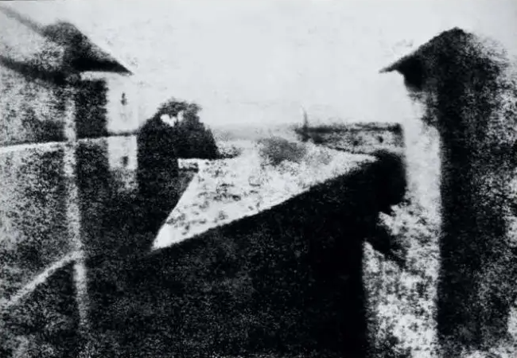
Fig.1 The earliest saved photographic image (Heliograph on pewter plate) from 1827 by Joseph Nicéphore Niépce, taken at Le Gras, France.
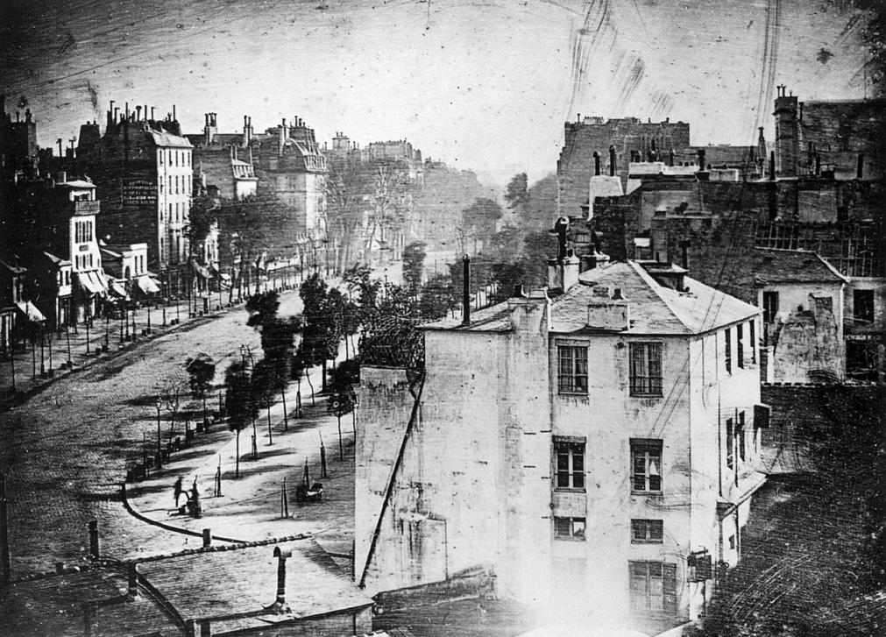
Fig.2 The Boulevard du Temple, a daguerreotype made by Louis Daguerre in 1838
In the subsequent decades following the invention of photography, the development of photosensitive materials underwent a profound diversification, giving rise to a multitude of processes. This evolutionary trajectory was propelled by a multifaceted interplay of artistic, technical, and commercial imperatives. While individual photographers ardently advocated for the expressive potential of specific processes and techniques, scientific inquiry, cognizant of the vulnerability of silver images to fading, gravitated towards the exploration of printing methods utilizing more enduring compounds such as carbon. The landscape of photography during its nascent fifty years was characterized by the introduction of a plethora of processes, each imbued with its own set of technical and artistic merits and shortcomings, collectively contributing to the rich tapestry of nineteenth-century photography (Fotland, 1970). Notable among these processes were the daguerreotype, cyanotype, wet plate collodion, and protein printing.
In recent decades, there has been a concerted endeavor to refine and elevate historical photographic processes. An important milestone in this progression was reached in 1884 with the invention of dry gel on paper, or film, by George Eastman of Rochester, New York. This innovation heralded a pivotal shift, obviating the need for photographers to transport cumbersome boxes of plates and hazardous chemicals. The advent of film cameras catapulted photography into the realm of mass consumption during the early twentieth century (Brayer, 2006).
This hand-printing process and other derivative processes that flourished between the 1840s and the beginning of the 20th century are referred to as historical photographic processes, or alternative processes (James, 2015; Persinger, 2014). Characterized by an array of photosensitive chemicals, presentation materials, environments, as well as nuanced tones and diverse image effects, these processes boast distinctive qualities that are undeniably captivating. They serve as a testament to photographers' relentless pursuit of technological advancement during that era and underscore the intrinsic connection between photography and painting within a specific historical context.
Digital technology has entered a period of rapid development since the turn of the 21st century, and photography has also experienced significant growth and popularity, becoming an integral component of modern civilization. As a result of technological advancements in digital photography, the generation of technically flawless photos is becoming straightforward, even for individuals without specialized training (Van Dijck, 2008). Digital photography may now be used extremely simply for informational and archival reasons, while traditional photography cannot compete in this regard. Therefore, digital photography occupies an absolutely dominant position in modern photography (Ang, 2018).
However, upon closer examination of digital photography's impact on artistic expression, a nuanced understanding emerges, revealing its influence on the creative process. Despite the vast array of subjects captured, digital photography often yields outcomes characterized by a degree of predictability, resulting in a homogenized aesthetic (Bardis, 2004). While the images produced are flawless in quality, digital images frequently lack the distinctiveness and individuality that define truly evocative art.
In this context, a growing cohort of artists is turning towards historical photographic processes to imbue their work with a sense of authenticity and uniqueness. By blending digital photography technology with the craftsmanship of historical processes, these artists craft visually arresting pieces that transcend the constraints of digital uniformity. Throughout the creative journey, photographers inject their personal vision at every stage, conducting a myriad of imaging experiments to produce bespoke results that resonate with their artistic sensibilities (Fried, 2008). Each piece thus emerges as a singular manifestation of the artist's creative vision, unfettered by the constraints of digital conformity. Engaging in historical photographic processes offers photographers a deeper sense of fulfillment and satisfaction, surpassing the purely technical achievements of digital photography. While digital shots may boast clear images and flawless colors, the tactile nature of historical processes allows photographers to immerse themselves fully in the creative process, manipulating imaging details with precision and finesse (Pauwels, 2015). This hands-on approach fosters a sense of connection and intimacy with the artwork, enabling photographers to imbue their creations with a sense of authenticity and individuality that is often elusive in the digital realm.
Furthermore, the unique materials associated with historical processes imbue artworks with a distinctive aesthetic quality that sets them apart from their digital counterparts (McIntyre, 2012). Whether it be the ethereal tones of cyanotype prints or the rich warmth of platinum/palladium prints, each historical process lends its own unique character to the final image, elevating it beyond mere visual representation to evoke a profound emotional response in the viewer. Moreover, as a vehicle for communicating ideas, historical photographic processes offer unparalleled opportunities for artistic expression. By embracing the inherent imperfections and idiosyncrasies of analog photography, artists can imbue their works with a sense of depth and authenticity that resonates with audiences on a visceral level. This authenticity serves to strengthen the work's aesthetic temperament, creating a robust artistic framework that endures the test of time (Luo, 2018; Ma, 2023).
Therefore, while digital photography may reign supreme in terms of technical proficiency and convenience, its dominance does not preclude the resurgence of interest in historical photographic processes. By marrying the precision of digital technology with the craftsmanship of historical processes, artists are forging a new path forward for photography, one that celebrates the rich legacy of the past while embracing the possibilities of the future. In doing so, they reaffirm the enduring power of photography as a medium for artistic expression and cultural exploration, ensuring its continued relevance in an ever-evolving world.
In China, photography entered the higher education system around the end of the 20th century and became one of the professional subjects offered by universities. Initially, only a select few art academies offered photography majors. However, with the advancement of digital photography and the rising demand for skilled photographers, an expanding number of comprehensive universities have introduced photography majors (Liu & Gao, 2010). These institutions predominantly focus on digital photography as their instructional content, guiding students in artistic creation and commercial photography using digital cameras. This is obviously in line with the progress of the times and the needs of society. However, Colleges and institutions rarely include the historical photographic processes in their curricula due to its time-consuming method, unstable image, unpredictable production process, and expensive cost. Consequently, the vast majority of students do not have the opportunity to interact with historical photographic processes during their professional studies, and their knowledge of these techniques is limited to book descriptions (X. Lin, 2014; Zhang, 2012).
In conclusion, it is evident that historical photographic processes offer distinctive advantages in artistic creation. However, for Chinese university photography students, whether the acquisition of historical photographic processes enhances their professional and creative abilities remains an unexplored research area, with no definitive answers provided by scholars thus far. Therefore, this study aims to bridge this gap by firstly analyzing existing data on historical photographic processes and subsequently conducting a 2-year longitudinal study in collaboration with the Photography Department of Wuhan University of Communication. The objective is to investigate the potential impact of integrating historical photographic processes into college photography curricula on students' professional and creative competencies.
The study's structure is outlined as follows: The introductory section provides a brief overview of the study, encompassing its historical context, background rationale, and identified research gaps. The subsequent section entails a comprehensive literature review, divided into two main segments. The first segment delves into contemporary photography's utilization of historical photographic processes, spotlighting two prominent contemporary photographers who employ historical photographic processes as their principal creative medium. This analysis aims to elucidate the distinct artistic allure of works crafted through historical photographic processes and their significance in the realm of artistic creation. The second segment scrutinizes the current landscape of photography education within higher education institutions. The Section 3 delineates the research methodology, offering an in-depth exposition of the 2-year longitudinal study. Section 4 presents the findings derived from the collected data. The concluding section encompasses discussions drawn from the findings and offers concluding remarks.
- Literature Review
2.1 Historical Photographic Processes in Contemporary Photography
Photography entered the period of "contemporary photography" after the 1970s (Lin, 2008; L. Lin, 2014). During this time, photography's aesthetic identity was established, and artists explored photography as a tool and medium for artistic expression. Contemporary photography's direction of development has also manifested in two forms: the exploration of integration with other art forms and the discovery of one's own artistic potential. The second type of research of photography itself is an immensely important path in contemporary photography, beginning with the physicality and materiality of photography and utilizing numerous historical processes to discover new artistic expressions of contemporary photography. The entire photography generation process is refined, which has three major relationships: subject, medium, photographer (Fig. 2). In historical photographic processes, the materiality of the medium corresponds with the subject, imparting a material quality to the work. This physical quality confers artistic worth upon the piece. Compared to digital photography, it possesses a powerful artistic empowerment (Bassnett, 2009).
In the context of current photography, historical photographic approaches might inspire the development of new independent creative methods. Through its radical independence, the artist is able to criticize the very supremacy of current visions imposed by the market using these techniques. True, the nature of the photographic medium stays unchanged, but the practitioner can construct his or her own vision through the employment of fairly basic materials whose primary focus is simple elegance (Krauss, 1999). Some practices of the historical photographic processes treat the process of creating a photograph and the resulting image as art. The traces generated by the photo-making process can be understood as the ‘registering of an emanation’ (Sontag, 2001; Wells, 2015), and should be kept fully functional through visible marks. These traces are a prolonged artistic expression that has a powerful contagious quality, allowing the viewer to capture the author's emotions beyond the work, resonate, and have an emotional connection with the image.
In 2003 McCaw, a photographer based in San Francisco, began taking pictures of the sun. Using large-format cameras that he builds himself; McCaw works outdoors, usually in the desert or by the sea. Instead of film, he places photographic paper in the camera so that each picture he creates is a unique paper negative. His exposures often last four hours or more. McCaw calls these works "Sunburns" because the rays of the sun, magnified by the camera's lens, actually scorch the paper negative, sometimes burning all the way through the paper base. The intensity of the light also causes solarization, reversing the tonal values so that the negative print appears as a positive image (Fig. 3) (Railo, 2018).
McCaw writes in his essay, “Notes on Watching Shadows Move” (Heckert, 2015):
“This project has transformed the way I think about photography and the world. Not only do I find myself using photographic materials in ways I hadn’t imagined, but I’ve also had to negotiate the physical realities of my subject as I never had to before. Having no control over the placement and movement of the sun, I have had to instead move myself and my equipment to specific locations, at specific times of the year, in order to capture the compositions I wanted.”
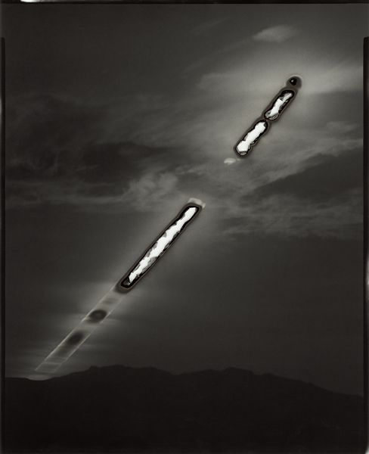
Fig.3 One of "Sunburns"
In this way, McCaw creates works with a distinctive materiality, a scar-like imprint that reflects the fragility and strength of nature while evoking a sense of impending annihilation. Unlike digital photos that lack physicality, McCaw's paintings have a strong aesthetic appeal and impact, and each piece is distinct. The subject matter of the photographs is conveyed to the audience via historical photographic processes and its shooting techniques, such that the audience has a strong artistic resonance and is incorporated into McCaw's art world (Heckert, 2015). From a document to a monument, McCaw inverts the historical inclinations of photography operators to incorporate monuments inside the discursive, standard frames of documents (Cristofovici, 1993). Additionally, McCaw encourages sublimation via technically flawed photos. Frustration in portraying the item paradoxically expresses its transformation into a single and pure form of presentation in which the object's increased presence engages the audience in ways that are not adapted to traditional sign systems (Moxey, 2008). Processes of sunrise and sunset can be interpreted as a reflection of the iterability of photographic processes (Tratnik, 2014), but through the use of alternative process photography, daily recurring events are transformed into exclusive representations far removed from the overproduction of ubiquitous and iterable images.
Sally Mann is a contemporary photographer whose work radiates the wildness of the Virginia countryside and whose conceptual expression is both radical and expansive. More importantly, her mastery of materials is unique and advanced, and this image is enough to shock everyone's heart. "Deep South" is one such series, shooting Virginia and Georgia, Mississippi, Alabama. Featuring defocused focus, scratches, and light leaks as a whole, these photographs convey reflections on life, time and history (Fig.4) (Parsons, 2008).
Sally Mann said in her own account related to "Deep South":
If you're a Southerner, you can't escape history; a Southerner lives uncomfortably between myth and truth. Observe this assortment of sorrow, seniority, honor, kindness, heresy, and rebellion. Resist the attractiveness of the wasteful body...... Before the Civil War, southerners enjoyed a paradisiacal existence as gentlemen and lords. The outbreak of war, however, disproved this illusion. Walking on the land of the south, I felt wounds and anguish...... Flannery Connor stated that the South is where the messiah will arrive, but I would reply that it is where death lurks. The images I captured throughout this awe-inspiring and devastating journey to the South remained etched in my mind: memory, loss, time, and love.
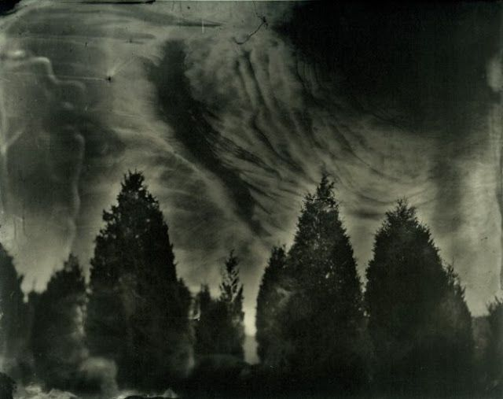
Fig.4 One of "Deep South"
Sally Mann used the technique of collodion wet printing and a lot of chemicals to change the tone in her creation. The texture brought by these hand-printing techniques perfectly expresses the sense of time in the work. Shot with a nineteenth-century camera and several antique lenses (Edge & Baylis, 2004). The use of these materials and techniques pursues a heavy atmosphere that is in line with the history of the American South. It has a chaotic look, gloomy tones, and dismal feelings. The material expression transports the viewer back into that era. Sally Mann uses reality to create fantasy, through the filming of the South, emphasizing the exploration of the meaning of life, the lament of time and the fascination with memory (Steward, 2000).
In the works of McCaw and Sally Mann, their artistic concepts have been well conveyed through the materials and techniques of historical photographic processes. Photography is a category developed by technology. The advancement of technology has made photography more convenient and enhanced image quality. This may also give the impression that newer and more modern technology are superior to older or more traditional processes (Farber, 1998). However, photography, particularly contemporary photography that focuses on aesthetic expression, cannot be evaluated just on the accuracy of the focus, contrast, tone, and cleanliness of the image. Instead, it should relate the author's creative aim to the expression of the content. Just like the three major relationships of photography mentioned earlier in this paper, in addition to the photographer, the medium that carries the image is also a very important link. Only if the work's form and subject matter are complementary can it possess significant artistic merit (Edge & Baylis, 2004; Nicholsen, 1999). Therefore, it is difficult to conceive what the Deep South would have been like if Sally Mann had depicted these moments with a crystal-clear vision.
Consequently, we can conclude that the historical photographic processes' material has a strong artistic temperament in the creation process. The high proportion of handwork clearly plays a role here, lending a touch of “artistry”. The chronological, pictorial, and experiential features of the materials used in historical photography processes determine the distinctive artistic qualities of each work created with these processes. Loris Medici once said that a photograph is not just an image, it is something tactile - a painting and an object. This is exactly what the traditional hand-printing process does in photography (Stoichita, 2008). As a form of photographic presentation, the traditional hand-printing process offers many interesting possibilities for presentation. Therefore, in the field of artistic photography, not only did the historical photographic process not disappear under the massive influence of digital photography, but due to the benefits of digital photography, artists have returned to the historical photography process with uncertain and unique production processes. Simultaneously, increasing numbers of individuals are attracted.
2.2 Historical Photographic Processes in University Teaching
We discussed the artistic qualities of historical photographic processes and the artistic expression of its materials earlier. In addition, through the analysis of the works of contemporary photographers, we can clearly understand the importance of historical photographic processes in contemporary photography creation. As a professional training institution, art college are responsible for cultivating talents in various fields for the art system. At the same time, art college, as " Academicism", produce artworks themselves. Therefore, as a powerful method of contemporary photographic creation, historical photographic processes should occupy a certain share of college photography curriculums.
Although historical photographic processes have a strong advantage in artistic photography creation, in the current photography teaching in China's universities, historical photographic processes are hardly included in the curriculum system. On this basis, questions posed as follows: whether the historical photographic processes should be specialty added in universities and how is the positive or negative influence on photography student?
Ellie Young's ‘The Salt Print Manual’ discussed the detailed process and method of salt printing (Young, 2011), as well as Sandy King's ‘Carbon Transfer Printing: A Step-by-Step Manual, Featuring Contemporary Carbon Printers and Their Creative Practice’ (King, Nelson, & Lockhart, 2019), Radostaw Brzozowski's ‘The Albumen Print’, Michael John Ware 's ‘The Chrysotype Manual’ (Ware, 2006) and other books have carried out significant study and discussion on the method of historical photography process (Eshbaugh, 2006). Presently, the enthusiasm of making historical photographic processes is increasing year by year in China. Nanjing University of the Arts held a grand exhibition of historical photographic processes in 2014, and Guangdong large-format photography association conducted a photography exhibition in 2017, where most of the works were produced by historical photographic processes (Zhu, 2018). At present, artists who create exhibition through historical photographic processes in China are still a relatively niche group. In the photography departments of traditional art universities such as Lu Xun Academy of Fine Arts, Beijing Film Academy, Nanjing University of the Arts and so on, they keep setting courses of historical photographic processes, however there is no detail information to directly show the influence of learning historical photographic processes on students' score and abilities.
Mark Cocks discusses photography education in 2009, he pointed out final-year students to have evolved the “hybrid” practice of shooting their images using traditional large- or medium-format cameras and film, and then scanning the negatives in order to produce digitized outputs. And he believes that This "hybrid" method and acknowledgment of digital multi-media practices have improved photography's status in the art market, allowing universities to focus on teaching artists rather than commercial practitioners. Digital technology may move the pedagogic focus from training to education, from gaining procedures that assert connoisseurship to amassing knowledge about photography's possibilities. The rapid pace of technological development is also causing classrooms to become democratic and imaginative (Cocks, 2009).
Daniel Rubinstein believe that photographic education must move away from the photograph as a work of art and focus on reproduction, duplication, and copying, which occur everywhere in academia and form the core of humanities and sciences knowledge creation. Photography education should include all image makers and users in a debate about how images are made, interpreted, circulated, and preserved and the ideologies they provide. One might expect that by taking this course, photography education will take its appropriate place in university education, and the question of the future will be what the usefulness of education without photography is. In college photography education, he believes that traditional photography processes and techniques should be abandoned in favour of a greater emphasis on digital technology and image content, as digital photography is more widely used and easier to use, which is in line with the current societal development (Rubinstein, 2009).
However, in researcher opinion, after more than ten years of rapid development of digital technology, digital photography has almost completely replaced traditional photography. Perhaps due to different national conditions, in China, most comprehensive universities (including science, engineering, agriculture, literature, economics, management, law, arts and other multi-disciplinary universities). Because the art major is not its main discipline, it will not invest a lot of money in the construction of the art discipline. Therefore, from the beginning of the photography major, there is only the content of digital photography. In authoritative art colleges (only art-related majors, and have certain status and achievements in the field of art), there are contents such as teaching of historical photographic processes, but this is a minority.
In essence, if the professional achievement can be improved as learning historical photographic processes, more and more universities are willing to set up historical photographic process’s courses. Although digital photography is the absolute mainstream in the photography education in universities at present, the unique handmade photography, tone and secondary artistic creation in the production process of historical photographic processes aren’t included in digital photography. Theoretically, it can guide students more in-depth understanding of the photography nature, more profound experience about how photographic light-sensitive materials influence on imaging. All these helpfully broaden the students' understanding of photography, the thinking mode of shooting, and enhance cognition of professional ability and score (Smith & Lefley, 2015). The handmade process, experimentation, variability and uniqueness of historical photographic processes effectively provide students unlimited possibilities in artistic creation (Kong, 2015). It's no longer like digital photography, which means the same camera parameters and location can take the same pictures. Twenty works in Elizabeth Opaleniuk's gelatin etching "Poetic Grace" were shot without little similarity. This is the accidental charm of historical photographic processes. Under the strong individuation, it will prompt photographers to invest vast energy and patience in the process of photo making and seek the best image effect with uncertain factors. This timeliness and experience will be bound to hone the photographer's artistic aesthetic ability and tellingly improve the artistic creation of photography ability.
Therefore, researchers believe that studying historical photographic processes can enhance students' professional and creative abilities. Teaching practice was conducted at the school where the researcher is located, and data was collected and evaluated in order to support the researcher's claim.
- Research Method
3.1 Model building and experimental design
Data collection came from the Class 2016 students(n=120) in photography department of Wuhan University of Communication. 20% of the 120 students in this class were randomly selected, and 24 students were selected to form an experimental group to carry out the data collection. Data collection started from September 2018 to June 2020 and proceeded according to the "group selection - group learning - graduation performance evaluation ". Detail works were listed here:
1．In the initial assessment stage, the comprehensive score was selected as control from September 2016 to June 2018(the first four semesters).
2．In the group learning stage, students were provided five historical photographic processes courses from September 2018, including Van Dyke, Wet-Plate Process, the cyanotype process, etc. and got the final score from five teachers from the photography department through three dimensions.
3．In the score evaluation stage, score distribution of experimental group (20% of students) and control group (80% of students) was evaluated based on the final graduation design.
The data collection is shown in the table below:
Table 1: Timeline data collection
time | stage | Data collection
Timeline node 1 | group selection | The comprehensive score of the first four semesters of students enrolled in 2016 were gathered and analyzed, which presented a normal distribution trend (Figure 2.1). Therefore, the score selection had credibility and validity. According to the distribution of scores, 24 students were randomly selected from different range, meanwhile the scores of selected group members were also arranged in a normal distribution, as shown in Figure 2.2.
Timeline node 2 | group learning | After five historical photographic processes courses, students took up their personal creation, then five professional teachers from the photography department were invited to blind evaluate and give corresponding scores.
Timeline  node 3 | graduation performance evaluation | Data were obtained by extracting the results of the final graduation works of all students enrolled in 2016.

Fig. 5 Class 2016 students scores trend

Fig. 6 Group members scores trend
3.2 method of measurement
The score of the first four semesters was measured by the average score of all photography courses. The final score of each required course consisted of the regular assignments score (40%), the final assignments score (40%), and the attendance (20%). These data objectively presented students’ professional ability, hard work and learning attitude in the first four semesters.
Group learning: to evaluate scores from the learning historical photographic processes group, three dimensions of learning attitude, creation presentation and mastery of the historical photographic process were listed to evaluate, accounting for 20%, 50% and 30% respectively. The data of learning attitude came from the attendance of group learning, preparation of pre-class materials and interactive performance in the course. The presentation data of the creation came from the blind review evaluation by teachers in photography department. The average score was obtained from three dimensions including visual language expression, picture composition and the idea transmission. The evaluation process was described as follows: (1) Five teachers from the photography department formed an evaluation group; (2) We explained the detailly definition and connotation of the three dimensions to the evaluation group, and five professional teachers reached a consensus on the evaluation criteria. (3) Five teachers in the photography department provided corresponding scores to each creation with full communication. The scores of each dimension ranged from 0-100, and these scores were averaged to measure the quality of the creation. In the process, we observed the material preparation, production process, proficiency and success rate of students the creation and obtained the data of conversant degree.
Graduation performance evaluation: The performance of their final graduation design was evaluated by total eight teachers in photography department based on these following dimensions. (1) Evaluation of students' workload, including preliminary research, difficulty degree of shooting content and shooting quantity. (2) The foresight of the theme and the certain practical significance. (3) The comprehensive consideration of design performance, consisting of composition, colour, light and shadow.
3.3 Courses of historical photographic processes
Establishing courses of historical photographic processes was deeply clarifying whether learning historical photographic processes technology was conducive to the development of photography major students. There were two main learning objectives for this course: First, understand the general process of several main historical photographic processes techniques as well as their creation rules and principles; Second, apply this knowledge in their personal historical photographic processes’ creations. Courses planed separate into five modules and learn a kind of historical photographic processes in each module. Meanwhile, students attempted to use this method to complete their creation. In the middle and end of each semester, one week was set aside to complete one module. Each module consisted of two stages. One was the theoretical stage, including the explanation and demonstration of knowledge and principles; the other was the practical creation stage, where students completed the semi-open proposition creation based on the theoretical content. Courses of this experimental historical photographic processes spanned 3 semesters, with a total of 100 class hours in 5 weeks. The specific course arrangement was provided in the following table 2.
Table 2: Five Modules’ Courses.
2018-2019-1
Module 1:The cyanotype process
Stage 1:  - Explanation of the principle of the cyanotype process and medicine configuration (1 class hour);  - Precautions for the cyanotype process and precautions for blue printing process (1 class hour);  On-site discussion and Q&A (2 class hours); | Stage 2:  - Use the cyanotype process for photography practice creation and communicate and discuss during creation (12 class hours);  Teachers comment and interact with students’ creations (4 class hours);
Module 2: Wet plate collodion process
Stage 1:  - Explanation of the principle of Wet plate collodion process and appreciation of works (1 class hour);  - Chemical solution configuration of wet plate process and notes on shooting (2class hours);  Wet plate collodion process shooting demonstration and discussion, Q&A (1 class hour); | Stage 2:  - Use Wet plate collodion process for photography practice creation and communicate and discuss during creation (12 class hours);  Teachers comment and interact with students’ creations (4 class hours);
2018-2019-2
Module 3: The albumen process
Stage 1:  - Liquid medicine configuration of the albumen process and theory explanation (1class hour);  - The operation process and toning skills of the albumen process (2 class hours).  On-site discussion and Q&A (1 class hour). | Stage 2:  - Use Wet plate collodion process for photography practice creation and communicate and discuss during creation (12 class hours).  Teachers comment and interact with students’ creations (4 class hours);
Module 4: Van Dyke process
Stage 1:  - Explanation of the principle of Van Dyke process (1 class hour).  - Operation process and precautions of Van Dyke process (2 class hours).  On-site discussion and Q&A (1 class hour); | Stage 2:  - Use Van Dyke process for photography practice creation and communicate and discuss during creation (12 class hours).  Teachers comment and interact with students’ creations (4 class hours);
2019-2020-1
Module 5: the platinum process
Stage 1:  - Platinum process principal explanation and operation demonstration (1 class hour).  - Platinum process medicine and paper production and development skills (2 class hours).  On-site discussion and Q&A (1 class hour); | Stage 2:  - Use platinum process for photography practice creation and communicate and discuss during creation (12 class hours).  Teachers comment and interact with students’ creations (4 class hours);

- Results
Collected data was analysed to verify the assumptions made in the early stage and two data acquisition nodes were described in Table 3.
Data from node 1 was experimental group who haven’t learnt the historical photographic processes, presenting no significant difference in comparison with the control group (P =0.785 >;0.05). Specifically, the average score of the experimental group was similar to that of the non-experimental group. Data from node 4 was obtained by the experimental group after learning historical photographic processes, which was obviously different from that of the non-experimental group (P =0.040 < 0.05). The average score of the experimental group was significantly higher than that of the non-experimental group, which proved hypothesis 1.
In the group learning stage of node 2, students learned historical photographic processes in five modules and obtained five times scores respectively: the score of module one: AVG=78.42, SD=6.52; the score of module two: AVG=79.083, SD=6.36; the score of module three: AVG=79.79, SD=6.17; the score of module four: AVG=80.04, SD=5.92; the score of module five: AVG=80.67, SD=5.58; Scores were arranged according to the sequence number of students (as shown in Fig. 7 and Fig. 8), meanwhile the standard deviation and average of the five modules’ average scores were calculated sequentially (as shown in Fig. 9 and 10). Drawing from these data, the standard deviation was gradually decreasing while the average score was gradually increasing, which proved the performance of the experimental students was also continuously improving.
Table 3: Timeline node1 and node 4 date analyze.
time | member | SD | AVG | P
Timeline node1 | experimental group (n=24) | 6.7 | 78.3 | 0.785
Timeline node1 | non-experimental group (n=96) | 7.8 | 77.9 | 0.785
Timeline node4 | experimental group (n=24) | 5.9 | 77.4 | 0.040
Timeline node4 | non-experimental group(n=96) | 5.7 | 74.8 | 0.040

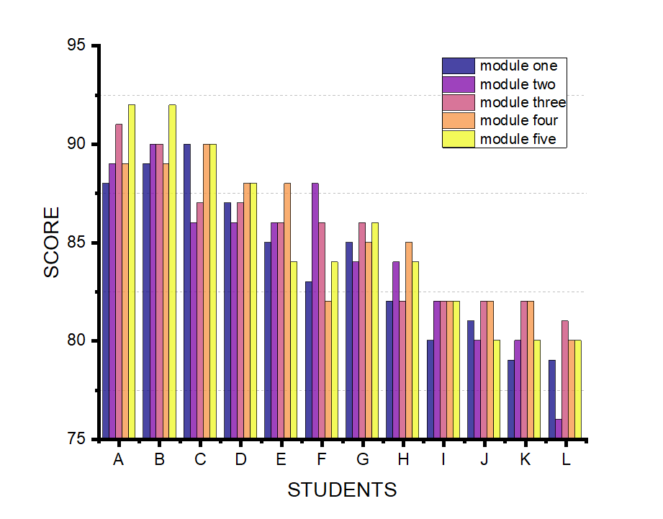
Fig.7 Group students’ score in five modules
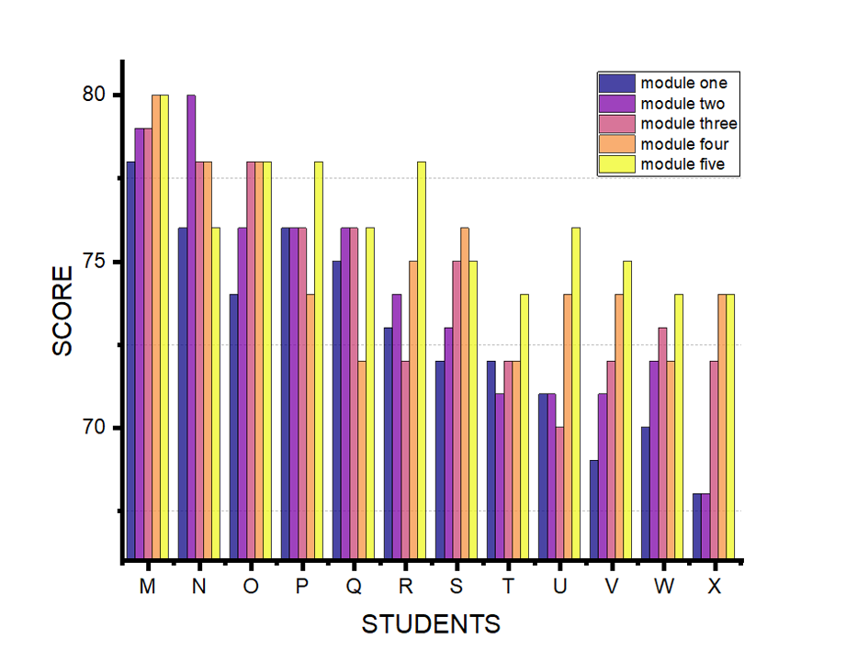
Fig. 8 Group students’ score in five modules
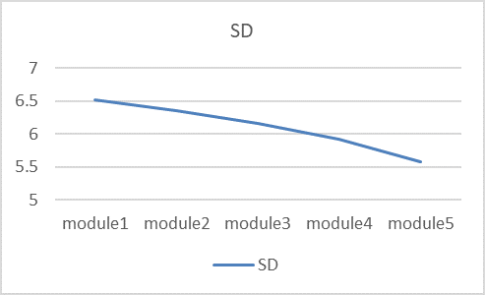
Fig. 9 Standard deviation of the five modules’ average scores
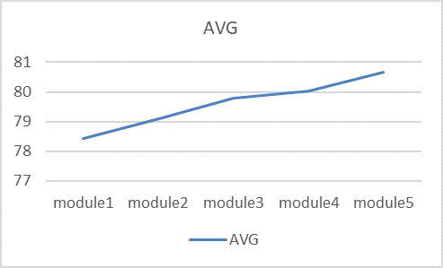
Fig. 10 Average of the five modules’ average scores
Due to the limited length of the paper, a case is selected for analysis here. Student B Li Wenbo performed very well in module 2 collodion wet plate photography and got the highest score of 90 points. In the course, because the photography department has only one large-format camera, it is more limited in the wet plate course. Through learning the principles of large-format cameras and discussing with teachers, finally gathered and built components by himself to create a useable large-format camera (Fig. 11). His work "Brave" records a doctor who treated him. During the imaging process, by using reagents, droppers and other tools for processing, the texture of germs is displayed on the picture, reflecting the brave state of medical workers in the face of the virus (Fig.12). From the creation to the picture performance and the materials, the teachers have praised it. His final scores are shown in the table below:
Table 4: Scores table
Evaluation dimension | reference standard | Average score given by 5 teachers
learning attitude | 1. No absenteeism during class, sufficient preparation of pre-class materials, and active interaction in class (80-100).  2. Sometimes being late, and only part of the content is previewed before class, and there is almost no interaction in class (60-80).  3. Sometimes being late and absences, no preview before class, and no serious study of the course content (<60). | 85
creation presentation | 1 The pictures are unique and have their own thinking, and they can flexibly use historical photographic processes materials. The composition is excellent. The picture can well express its creative ideas. (80-100)  .2 Be able to reflect the characteristics of historical photographic processes materials in the picture, be able to arrange the picture elements reasonably. The idea of the creator is hard to see in the work (60-80).  3 The picture elements presented in the final work are chaotic, unable to convey the creator's thinking, and not aesthetically pleasing (<60). | 89
Mastery of the historical photographic process | 1 Able to master the various procedures in the imaging process and the metering of reagents and can complete the artistic performance of the material through intervention during the imaging process, with a high success rate (80-100).  2 Not very proficient in the whole imaging process, but able to complete the work, the quality of the final work is not stable (60-80).  3 Inability to complete the imaging process independently, high failure rate, and poor-quality final work (<60). | 95
By calculating his final score is 85*0.2+89*0.5+95*0.33=90. The scores of other students are also calculated through this process.
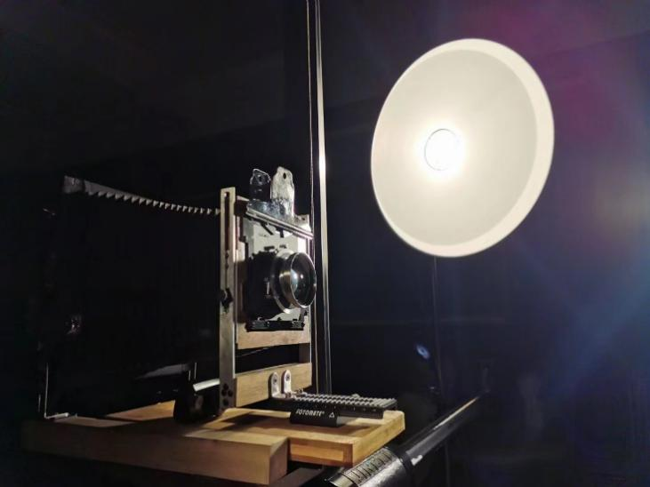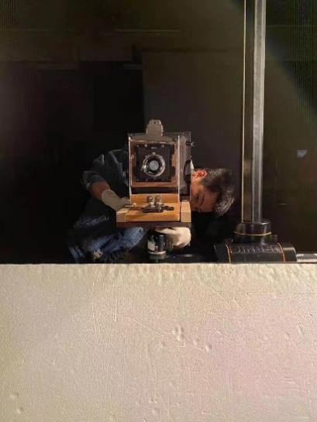
Fig. 11 Li and large-format camera made by himself
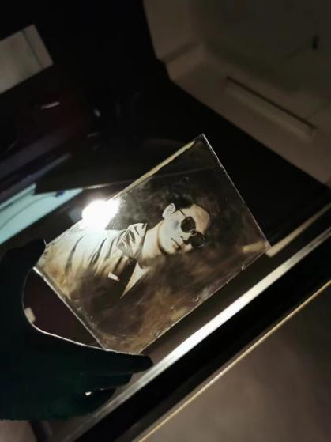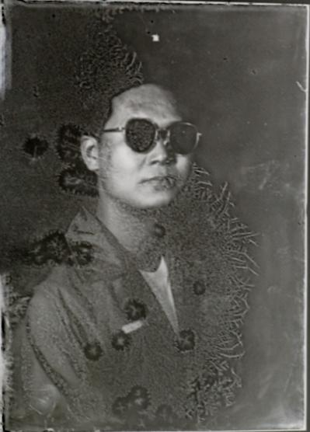
Fig. 11 “Brave” shoot by Li Wenbo
By comparing data gathered from the teaching exploration of historical photographic processes, we can conclude that students' professional and creative abilities can be enhanced by learning historical photographic processes. The study of historical photographic processes has increased students' interest in the investigation of photography's essence. Some students prefer to use historical photographic processes as a creative production strategy for their graduation projects (Fig. 11-Fig. 14). In these works, we can experience the creative use of early photographic processes into the creation. Some students have made changes in new creative methods caused by the intervention of modern digital technology into historical photographic processes. Some students turned from the expression of conceptual content to the retrospect of historical photographic processes. Some students have tried the comprehensive application of historical photographic processes in cross-media materials. Indeed, in such an era of image carnival, it is necessary for college photography education to return to the original point, so that students can experience the search for a new direction of photography creation in an era full of "aura".
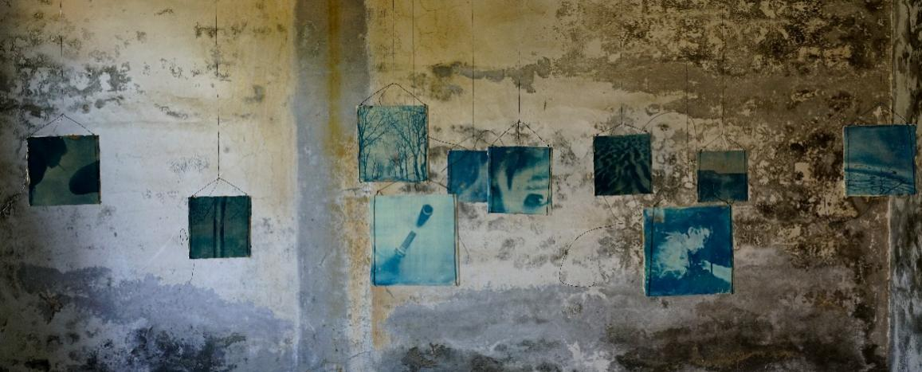
Fig. 11 "Dream's Displacement and Homecoming" exhibition scene photo-shot by Shang Xuebing
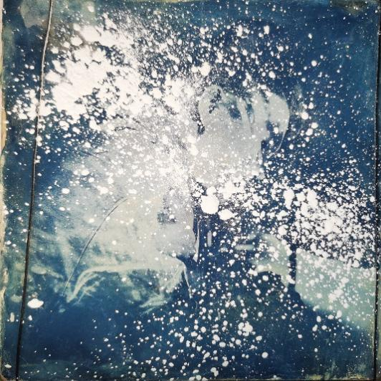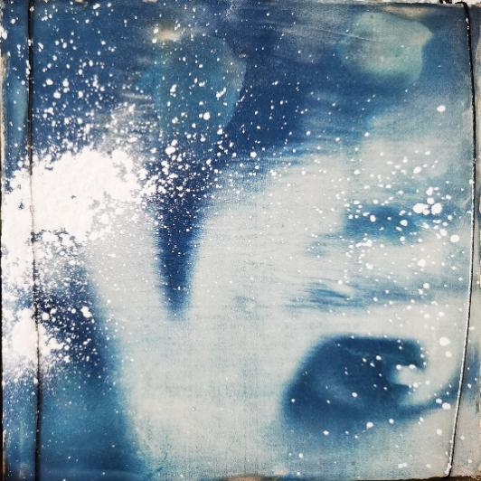
Fig. 12 "Dream's Displacement and Homecoming" shot by Shang Xuebing
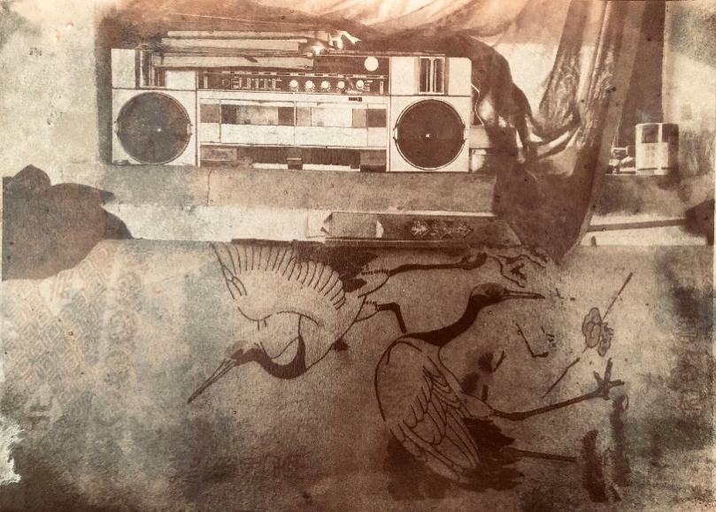
Fig. 13 "Trace" shot by Li Yinuo
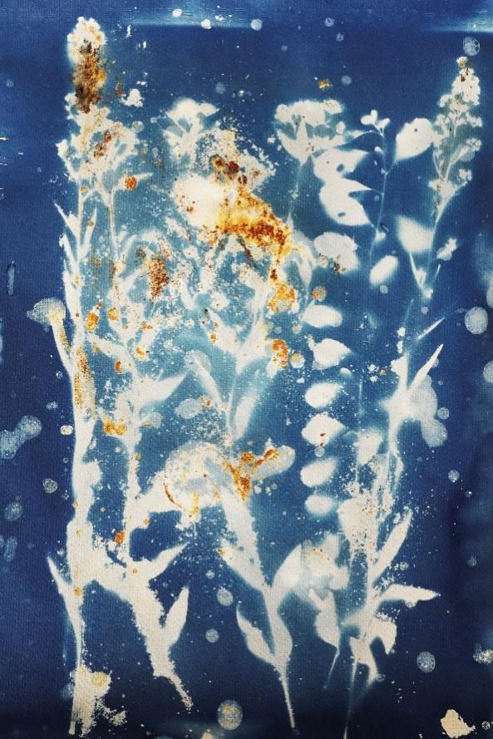
Fig. 14 " Grow upwards" shot by Chen Yanlin
- Discussion and Conclusion
The photography major is a latest established art major in universities. In Comparison with other majors, training programs for students still need be revised in the exploration and the curriculum should be gradually improved in the discussion. As more and more students enter the photography major, the theme of photography education in universities has been constantly proposed and discussed. Based on the discussion of curriculum setting of historical photographic processes in universities, this study tends to analyse the professional ability with or without historical photographic processes training for two years. The results show that in the teaching of photography majors, teaching students the relevant knowledge and skills of historical photographic processes will ultimately have a positive impact on the students' professional ability.
From the perspective of research methods, this study has the following advantages compared with other studies, data obtained by students through learning historical photographic processes are objective and also based on the longitudinal tracking of the same students from the beginning of historical photographic processes to the completion of learning and graduation, which is of certain research value.
Through the overall analysis of the study, it still exists some limitations and need to be further explored in the future. First of all, from the perspective of the research group, the sample number is still a little small and not objective enough, which can only represent the positive influence on a certain extent. Secondly, as it is the first time to establish the photography workshop, there are still some deficiencies in the implementation process. In the later stage, teaching content, creation form and curriculum arrangement need to be further optimized. Thirdly, from the perspective of the universal conclusion in this study, there are great differences between universities. Whether the course of historical photographic processes can be added in other universities, as well as the course content still need to be discussed and planned.
As the development of science and technology, photography has been greatly affected. From the traditional historical technology to digital photography and intelligent algorithms, photography has become an effortless operation. Even if digital photography is the predominant way of photography, historical photographic processes nevertheless hold a place in contemporary photography art. Its unique materials and material aspects have also endowed the photographic works with profound artistic qualities, giving them a strong artistic perception. This makes the visuals presented by the historical photographic processes materials themselves combined with the themes and ideas expressed in the works, bringing people more thinking. Through the application of historical photographic processes in creative creation, the long-term process of picture capture will strengthen the connection between the creator, the medium, and the object. Simultaneously, the medium is experimentally trimmed for an extended period of time, and these traces are incorporated into the final work, giving it a profound aesthetic significance. In addition, it transforms the entire photographic process into a creative experience. Visually and physically, the piece creates an unforgettable imprint on the observer in its ultimate presentation. So, this also explains why in the current environment, the use of historical photographic processes for artistic creation is becoming more and more popular.
This study also actively discusses the necessity for students to learn historical photographic processes in the course construction of photography major in colleges and universities, which can improve students' professional ability in photography from many aspects. Digital photography indeed has a great cost advantage and convenience, due to technology made photography much easier. The omnipotence of digital cameras and the powerful repair capability of software in the process will cause students to disregard the issues requiring attention in the early stages of the photography process, including lighting, composition, and exposure management. At the same time, the convenient and fast imaging allows students to press the shutter blindly and aimlessly during the exercise, ignoring the consideration about the picture during the shooting. These are not rigorous and professional for students majoring in photography, but also make students' basic skills become unstable. However, historical photographic processes on the contrary, it makes the whole process slow down, and each shot becomes unique, making people more focused on the generation of each link. In this process, there is a very strong sense of ritual, which is also the unique value of historical photographic processes. Therefore, the establishment of historical photographic processes, which combines handwork and art, is needed to consolidate students' photographic foundation and improve their artistic creation level.
However, it is unrealistic to add historical photographic processes module to the training program overnight in universities. The study of historical photographic processes technology by a large number of students requires universities to invest in infrastructure, and how to balance the input-output ratio requires the coordination of all departments. Thus, in the curriculum system of universities, the course of historical photographic processes can be included as an elective course. Students can choose the course of their own free will, and universities need to invest only relative low infrastructure to help build the course. Students who voluntarily participated tend to make higher progress at the end of the course than non-voluntary students.

Data Availability Statements
The datasets generated during and/or analyzed during the current study are available from the corresponding author on reasonable request.

References
- Ang, T. (2018). Digital Photography an Introduction: Penguin.
- Bardis, A. (2004). Digital photography and the question of realism. Journal of Visual Art Practice, 3(3).
- Bassnett, S. (2009). Archive and affect in contemporary photography. Photography and Culture, 2(3), 241-251.
- Benjamin, W. (1972). A short history of photography. Screen, 13(1), 5-26.
- Brayer, E. (2006). George Eastman: a biography: University Rochester Press.
- Cocks, M. (2009). The Enduring Fragility of Chemicals and the Software Aesthetic. Photographies, 2(2), 185-201.
- Cristofovici, A. (1993). La part de l'ombre: essais sur l'expérience photographique. In: JSTOR.
- Edge, S., & Baylis, G. (2004). Photographing children: the works of Tierney Gearon and Sally Mann. Visual Culture in Britain, 5(1).
- Eshbaugh, M. L. (2006). Alternative Photography Processes: A Worker's Guide: RMR Press.
- Farber, R. (1998). Historic Photographic Processes: A Guide to Creating Handmade Photographic Images: Simon and Schuster.
- Fotland, R. (1970). Optically Developed Free-Radical Photosensitive Materials. The Journal of Photographic Science, 18(2), 33-37.
- Fried, M. (2008). Why photography matters as art as never before: Yale University Press New Haven.
- Gu, Z. (2005). World Photography History: Zhejiang Photography Publishing House.
- Heckert, V. (2015). Light, paper, process: reinventing photography: Getty Publications.
- James, C. (2015). The book of alternative photographic processes: Cengage Learning.
- King, S., Nelson, D., & Lockhart, J. (2019). Carbon Transfer Printing: A Step-by-step Manual, Featuring Contemporary Carbon Printers and Their Creative Practice: CRC Press.
- Kong, N. (2015). The Verbal Characteristics of Classical Shooting Techniques. Chinese photographers, 04.
- Krauss, R. E. (1999). Reinventing the medium. Critical inquiry, 25(2), 289-305.
- Lin, L. (2008). History of Photographic Thought: Zhejiang Photography Publishing House.
- Lin, L. (2014). Contemporary Conceptual Photography. Shanghai Artist(2), 7-11.
- Lin, X. (2014). Discussion on existing problems in photography education in Chinese universities. Theater House(18), 218-218.
- Liu, Y., & Gao, J. (2010). The current situation of photography education in colleges and universities and thoughts on its teaching philosophy. Art Grand View(5), 173-173.
- Luo, B. (2018). An Analysis of the Artistic Photography of Digital Technology Creation. Paper presented at the 4th International Conference on Arts, Design and Contemporary Education (ICADCE 2018).
- Ma, Y. (2023). Revival and development of classical photography in contemporary perspective. Paper presented at the SHS Web of Conferences.
- McIntyre, P. (2012). Photography: Art, Craft and Their Symbiosis. In Creativity and Cultural Production: Issues for Media Practice (pp. 148-159): Springer.
- Moxey, K. (2008). Visual studies and the iconic turn. Journal of Visual culture, 7(2), 131-146.
- Nicholsen, S. W. (1999). Adorno, Benjamin and the aura: an aesthetics for photography. Adorno, Culture and Feminism, London: Sage, 41-65.
- Parsons, S. (2008). Public/private tensions in the photography of Sally Mann. History of Photography, 32(2), 123-136.
- Pauwels, E. (2015). Resetting the camera’s clock: Sarony, Muybridge & the aesthetics of wet-plate photography. History and Technology, 31(4), 482-491.
- Persinger, T. (2014). Photography Beyond Technique: Essays from F295 on the Informed Use of Alternative and Historical Photographic Processes: CRC Press.
- Railo, A. (2018). The Photographic Capacity: Intentionality and Direct Connection in the Artwork of Meghann Riepenhoff, Klea McKenna and Chris McCaw. San José State University,
- Rooseboom, H. (2014). What's wrong with Daguerre? In Photography and its Origins (pp. 29-40): Routledge.
- Rubinstein, D. (2009). Towards photographic education. Photographies, 2(2), 135-142.
- Smith, P., & Lefley, C. (2015). Rethinking photography: Histories, theories and education: Routledge.
- Sontag, S. (2001). On photography (Vol. 48): Macmillan.
- Steward, J. C. (2000). The camera of Sally Mann and the spaces of childhood. Michigan Quarterly Review, 39(2), 365.
- Stoichita, V. I. (2008). The Pygmalion Effect: From Ovid to Hitchcock (Vol. 2): University of Chicago Press.
- Tratnik, P. (2014). Hacer la presencia: fotografía, arte y (bio) tecnología: Herder.
- Van Dijck, J. (2008). Digital photography: Communication, identity, memory. Visual communication, 7(1), 57-76.
- Ware, M. (2006). The Chrysotype Manual: The Science and Practice of Photographic Printing in Gold: Ffotoffilm.
- Wells, L. (2015). Photography: a critical introduction: Routledge.
- Whitmire, V. (1992). Joseph Nicephore Niepce 1765-1833. PSA Journal, 58(10), 13-14.
- Young, E. (2011). The Salt Print Manual: Lulu. com.
- Zhang, Q. (2012). Some thoughts on current photography education in colleges and universities. Art Education Research(4), 129-129.
- Zhu, R. (2018). Research on the Value of Historical Photography Processes. (Master), Nanjing University of the Arts,

