A Bibliometric Analysis and Latent Dirichlet Allocation Topic Modelling of Digital Literacy in Education, 2006-2025
Liangjie Fan^{1*}

¹ Department of Educational Studies, Academy of Future Education, Xi'an Jiaotong-Liverpool University, Suzhou, P.R. China
Corresponding Author*: Liangjie Fan E-mail:
1592321480@qq.com

ARTICLE INFO | ABSTRACT  Digital Literacy (DL) has emerged as a pivotal competence for individuals to embrace the digital era with the rapidly advancing information and technologies. This paper uses bibliometrics and topic modeling to examine 1,421 research articles on DL in education published in the Web of Science from 2006 to 2025, encompassing annual publication trends, relevant sources, countries, research topics, and trends. Key findings displayed that studies on DL have clocked staggering growth, with the United States and the United Kingdom contributing the most in this field. Additionally, the author used latent Dirichlet allocation (LDA) topic modeling and keyword analysis to depict the 12 latent topics in DL, discussed the plausible reasons for these varied patterns, and proposed implications based on the research findings.
Keywords
digital literacy
digital education
topic modeling
bibliometric analysis

Published:
7 March 2026

- Introduction
Under the milieu of a rapidly advancing era of information and technology, digital literacy (DL), a combination of both technical and cognitive abilities in the effective use of information and communication technologies to find, evaluate, create, and communicate information (American Library Association, 2023) has emerged as an imperative skill for individuals to engage and adapt in 21st-century communication and social networks. The opportunities that DL can bring are abundant. Firstly, DL emphasizes the skills of navigating and searching for digital information, enabling people to effectively and fully utilize available digital information in the era of electronic information explosion (Reddy et al., 2021). Secondly, DL also includes skills in critical evaluation, filtering, and decrypting digital information, which can enable individuals to cope with information overload and discern the authenticity of information, thereby making the right decision (Kabakus et al., 2023). Besides, although the digital society has brought many benefits to society and individuals, it also poses challenges, such as threats to personal privacy data (Taddeo, 2020), while the DL also emphasizes digital ethics and security, which can enable individuals to better combat threats in the digital age and protect their data security. Hence, possessing DL could not only empower individuals to access and navigate through a vast sea of digital information, enabling them to seek out high-quality content but also cultivate their ability to remain cognitively alert amidst the deluge of information and safeguard their private data from potential breaches. Notably, its benefits are still expanding as the evolving conceptions of it continue to unfold (see Section 2.1 for details) and have been taken as an essential attribute of a discerning citizenry and a competitive workforce (Weninger, 2023). Hence, how to cultivate citizens with DL has become a concern for educational researchers.
Unfortunately, the DL education is still facing challenges. For instance, in terms of infrastructure construction, the digital divide is extremely severe, there is a clear imbalance in the distribution of digital resources between countries, and urban and rural areas, which affects students' learning experience and knowledge acquisition. Secondly, regarding education policies, due to the different backgrounds of various countries, it is worth paying attention to how to develop digital standards and training courses that are suitable for their citizens. In addition, teachers' DL needs to be improved. Specifically, there is still a shortage of teachers with high-level DL, which directly affects students' learning outcomes as teachers are unable to fully utilize digital tools and resources for teaching. Meanwhile, some teachers' resistance or fear of digital technology may also hinder the promotion of DL education.
Faced with these opportunities and challenges, lots of scholars have engaged in discussing the development of DL by conducting empirical research. However, there is a relative scarcity of review articles, which hinders researchers from gaining a comprehensive understanding of the current research landscape and future trends in the field. Hence, the present study adopts a bibliometric approach to review DL in education. The primary objective is to provide a comprehensive understanding of the current research status, distribution of topics, and topic trends to offer guidance for future research endeavors.

- Literature Review
2.1 What is DL?
The proposal of DL can be traced back to 1997. Glister (1997) defined it in educational terms, ‘the ability to understand and use information in multiple formats from a wide range of sources when it is presented via computers’ (p.1). In this seminal article, the author characterized DL as an ability to search and evaluate textual and multimedia information online (Meyers et al., 2013). Likewise, Eshet (2002) proposed that DL encapsulates skills of retrieving, evaluating, utilizing, and deciphering the data. These early interpretations have taken DL as a distinct skill set and mostly focused on individuals' technical ability to process digital information. Till now it is still echoed by a recent model proposed by Fraillon et al. (2019), which claimed that DL covers skills on 1) one’s understanding of computer use, 2) digital communication, 3) producing information, and 4) gathering information.
Henceforward, DL as a fluid term, continues to evolve and refine, with different scholars emphasizing different aspects. Specifically, the interpretation of DL is evolving from a single dimension that originally focused on technical prowess to a multi-dimensional one and enriching it into a ‘catch-all’ umbrella term. For instance, besides technical skills, Lankshear and Knobel (2003) added some cognitive elements and outlined DL as encompassed by three interconnected dimensions. The first dimension, ‘operational’ refers to individuals’ competence in utilizing various tools, procedures, and techniques. The second dimension, labeled as ‘cultural’, emphasizes understanding digital texts within their socio-cultural contexts. Lastly, the third dimension, known as ‘critical’, emphasizes the awareness that digital literacies are socially constructed. Beyond this footstep, some scholars like Ng (2012), Tuamsuk and Subramaniam (2017) added a socio-emotional dimension to DL. In this viewpoint, DL also encompasses appropriate online conduct and the necessary sensitivity for it (Eshet, 2004).
Hence, the definition of DL appears to be an evolving concept that varies based on the research background of different scholars and factors such as technological advancements and changes in society. To date, there remains a lack of consensus regarding the definition of DL, highlighting the divergent perspectives within the field of study. Previous literature reviews have extensively discussed the definition of DL (see section 2.3), but it is beyond the scope of this bibliometric review to delve into that discussion. Hence, it will not be reiterated here.

2.2 Why study DL?
As aforementioned, the development of technology has given rise to various new literacy, similar to DL, media literacy, information and technology (ICT) literacy, digital competence, computer literacy (Law et al., 2018) and so on. The reasons the author chose to delineate the contour of the study on DL are twofold. Firstly, in current research, there is a prevailing consensus that the concept of DL encompasses not only the previously mentioned concepts but also extends to broader aspects. For instance, Trilling and Fadel (2009) consented that DL encompasses three components, namely, ‘media literacy’, ‘ICT literacy’, and ‘information literacy’. Likewise, Chetty et al. (2018) categorized DL into five distinct domains: ‘information literacy’, ‘computer literacy’, ‘media literacy’, ‘communication literacy’, and ‘technology literacy’. In addition, as mentioned in Section 2.1, DL encompasses cognitive, social, and emotional dimensions, as well as safety, privacy, and ethical issues related to digital information. Therefore, in terms of defining concepts, DL has a broader scope compared to other literacies. Secondly, DL has been widely promoted by a myriad of international organizations like UNESCO, the European Commission, OECD, ATCS, and so on. As a result, its popularity and acceptance will be relatively broad. Overall, in terms of the breadth and dissemination of concepts, the author chose DL as the research focus.

2.3 Review studies in DL in education
Previous literature reviews on DL in education have adopted different focuses, leading to diverse contributions (See Table 1). Some reviews emphasized the discussions of DL definitions and frameworks. Specifically, by utilizing content analysis, Martinez-Bravo, et al. (2022) conducted an exploratory review of 70 documents related to DL framework proposals put forward by eight international educational institutions, Subsequently, a sixth dimension of DL was identified (i.e., critical, cognitive, social, operative, emotional and projective).
In addition, some authors not only reviewed the definition of DL, but also summarized its education practical significance in different social contexts. For example, Reddy et al. (2021) conducted an integrative review, which combined the definitions and components of DL, and it underscored the paradox that despite a growing youth population, the notion of DL in the South Pacific region remains in its infancy. Hence, the authors advocated for higher education institutions to use the synthesis herein to refine DL initiatives. Finally, practical measures are proposed, encompassing the enhancement of information technology infrastructure, the allocation of increased training opportunities, and so on. Likewise, Pangrazio et al.’s (2020) review compared the DL as a concept, educational initiative, and tensions in three contexts (i.e., English, Spanish, and Scandinavian). This review indicated that the definition of DL is subject to ongoing debate in the English context, whereas the focus in the Spanish and Scandinavian contexts lies more on its application. In terms of tensions, the authors discussed differing perspectives on DL as either a cognitive process or a social practice, highlighting the implications for teaching methods. They also noted the predominant international emphasis on general and instrumental aspects of DL, neglecting the importance of social and localized approaches. Furthermore, the review addressed the limited expansion of DL education, primarily attributed to the separation of socialization methods from school curricula, and the controversies surrounding its objectives and challenges posed by international standardized testing. Unlike previous reviews on the definition and educational practical of DL, Gutiérrez-Ángel, et al. (2022) conducted a systematic literature review on 22 empirical studies on DL in the context of universities from 2010 to 2021, analyzing and sorting out the psychoeducational and learning variables that affect DL. Through a comparison of research before and after the pandemic, the authors found that the use of technology in the education sector has significantly increased and these empirical researches not only follow the previous survey route but also focus on measuring DL and exploring the impact of some social-biographical variables (i.e., age, gender) on DL. In addition, research on psychoeducational variables has become a rising trend, including academic motivation, self-efficacy, effort expectations, and so on.
Two reviews most relevant to this study are Audrin & Audrin’s (2022) and Tinmaz et al.’s (2022) and systematic literature reviews. Specifically, Audrin & Audrin’s (2022) article reviews 1,037 research articles on DL published between 2000 and 2020, with a focus on using text mining methods to explore DL and related concepts in education. In addition, the study identified six key factors (i.e., information literacy, developing DL, digital learning, ICT, social media, and 21st-century digital skills). Based on this, these factors are classified into three main streams (i.e., DL, digital learning, and 21st-century digital skills). In tandem, Tinmaz et al’s (2022) review depicted the main themes and classifications of DL. Through content analysis of 43 literature from 2000 to 2021, four themes were identified: DL, digital competencies, digital skills, and digital thinking. Unfortunately, the limited amount of literature this study includes will inevitably hinder the classification of DL research topics. Besides, this review only identified the main themes of DL and did not analyze how these topics were distributed or evolved over the years. Moreover, it is worth noting that the authors also called for an increase in bibliometric reviews at the end of the article. ‘This visual approach will assist in realizing the big picture within the DL framework.’ (Audrin & Audrin, 2022)

Table 1. Comparison with previous reviews of the DL in education
Authors | No. of articles | Period | Methods | Major findings
Reddy et al. (2022) | Not mentioned | Not mentioned | Integrative review | 1)Combine the definition and components of DL  2)Active components of DL in the Pacific  3)Importance and Impacts of DL on Higher Education in the South Pacific  4)Future directions of DL in the South Pacific
Audrin & Audrin (2022) | 1037 | 2000-2020 | Systematic  review & Text  mining | 1)Explore the place DL hold in literature in education and learning  2)Explore how the DL is conceptualized in the educational context  3)Reveal the main research streams on DL
Tinmaz, H., et al. (2022) | 43 | 2000-2021 | Systematic  review | 1) discover the main themes and categories of the research studies regarding DL
Gutiérrez-Ángel, N et al.  (2022) | 22 | 2010-2021 | Systematic  review | 1)explore the psychoeducational and learning  variables that are related to DL  2)reveal the current situation internationally regarding DL in all disciplines in pre-service teacher education  3)compare the differences in DL requirements pre and post pandemic
Martinez-Bravo, M. et  al. (2022) | 70 | Not mentioned | Exploratory review | 1)identify the 6 dimensions of DL based on  content analysis (i.e., critical, cognitive, social, operative, emotional and projective)
Pangrazio et  al. (2020) | 30 | Not mentioned | Comparative review | 1)compare the DL as concept, educational  initiative and tensions in three different contexts (i.e., English, Spanish, and Scandinavian)
This study | 932 | 2006-2025 | Bibliometric review & Topic modeling | 1) reveal the status quo of the DL publication in education  2) identify the research topics in DL research 3) predict the future research directions of DL in education

From the above, it can be observed that the existing literature reviews on DL in education mainly focus on its definition within educational contexts, as well as exploring its implementation in specific language contexts. There is relatively less attention given to the current state of published articles, the potential themes, and future trends in research. Moreover, previous studies have predominantly relied on systematic reviews as their methodological approach, with limited utilization of bibliometric review methods. Additionally, the volume of literature examined in most reviews is comparatively smaller than what this study aims to cover, possibly inhibiting a holistic picture for researchers. Therefore, this study aims to investigate the publication status of DL in education, identify existing themes, examine their distribution, and explore future development trends. Here are the research questions:

RQ1: What is the status quo (annual scientific production, most relevant sources, countries, etc.) of the DL publications?
RQ2: What are the most prominent research topics of DL research?
RQ3: What are the future research directions?

- Data Collection
Before visualizing and analyzing the results, the following steps were taken (refer to Figure 1). Firstly, the author chose the Web of Science Core Collection as the literature resource, known for its comprehensive bibliographic information. This database has been widely used in numerous review studies (e.g., Liu et al., 2021). Secondly, to ensure article quality, only the Science Citation Index Expanded (SCI-EXPANDED), Social Sciences Citation Index (SSCI), and Arts & Humanities Citation Index were considered. Secondly, the Boolean expression (TS=("digital literacy") OR TS=("digital literacies") OR TS=("digital competency") OR TS=("digital competencies") OR TS=("digital capability") OR TS=("digital capabilities") OR TS=("digital skill") OR TS=("digital skills") OR TS=("digital ability") OR TS=("digital abilities")) AND (TASCA==("EDUCATION EDUCATIONAL RESEARCH" OR "PSY-CHOLOGY EDUCATIONAL" OR "EDUCATION SCIENTIFIC DISCIPLINES" OR "EDUCATION SPECIAL") AND LA==("ENGLISH")) was used to search for literature based on keywords, subject field, document type, and language. Additionally, the search was limited to publications from the year 2006 to 2025. Finally, a total of 1,421 full records were retrieved from the database. Fourthly, in the topic modeling section, the author selected abstract text as the research object. And before this, preprocessing was carried out, including deleting punctuation, and stop words (cf.,Yin & Yuan 2022). The stop words eliminated included pronouns, conjunctions, and prepositions that do not represent the research article's topic. Additionally, terms commonly found in abstracts but with low information content about the article, such as ‘study", "studies," etc. were removed. Furthermore, highly relevant but ambiguous terms related to the topic, such as "digital," "literacy," "competency," and so on were also removed. In total, 568 stop words were eliminated from the analysis. Figure 2 shows the process of data analysis.

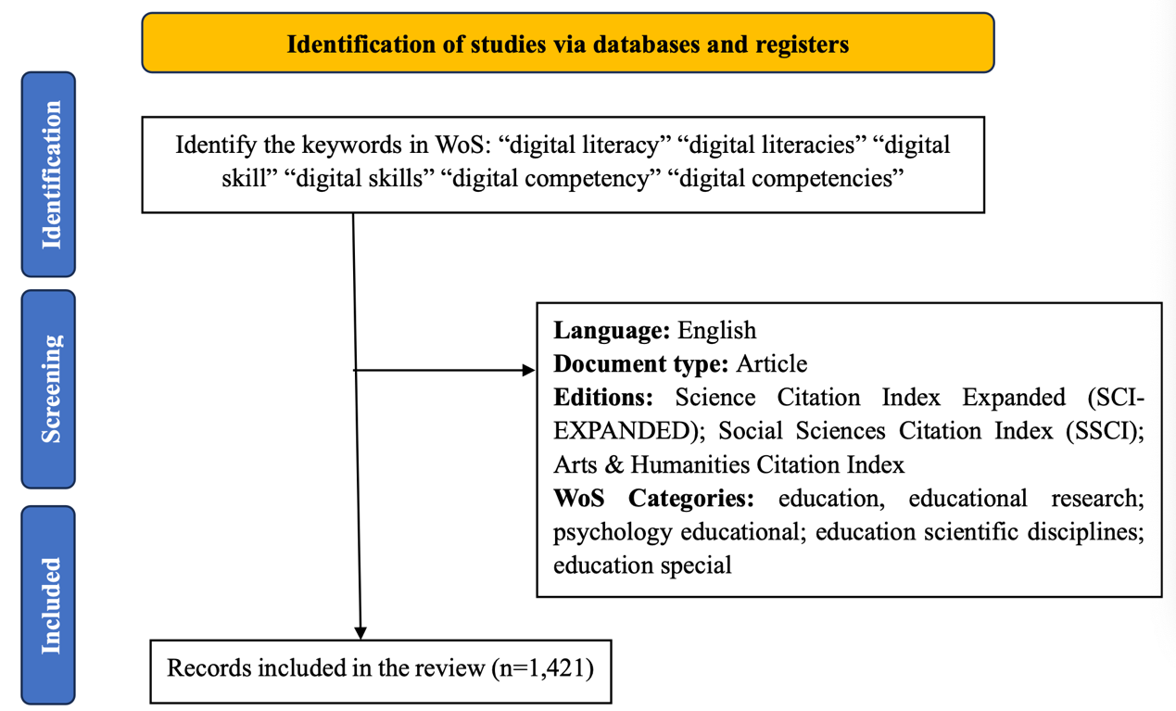
Figure 1. The PRISMA flow chart

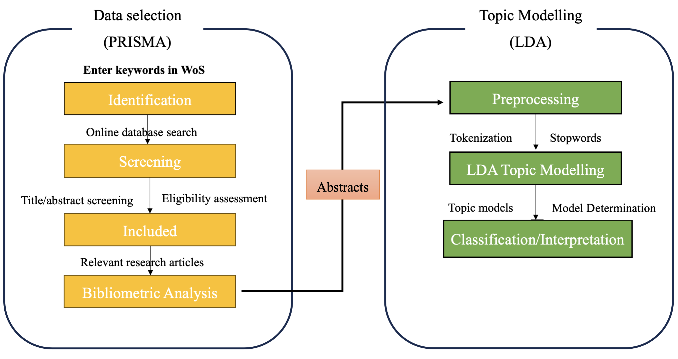
Figure 2. Procedures of data analysis

- Data Analysis
Based on the 1,421 records, the author chose bibliometric analysis to address the RQ1, which was proposed by Pritchard (1969) and described it as the application of mathematical and statistical methods to demonstrate the processing of textual information, as well as the nature and trends of the development of a particular discipline, through the calculation and analysis of different levels of textual information. When it comes to RQ2, latent Dirichlet allocation (LDA), a text-mining technique that relies on topic probability (Jelodar et al., 2018) and semantic similarity (Blei et al., 2003) was employed, which can reveal the topics covered in the text. The optimal number of topics in LDA can be determined using perplexity and coherence measures. Perplexity quantifies the uncertainty of a trained topic model in identifying document topics (Cao et al., 2009). A lower perplexity indicates better topic recognition. Coherence scores assess the semantic similarity between words related to a topic (Deveaud et al., 2014). Higher coherence indicates stronger interpretability of the model. Therefore, an ideal number of topics should have low perplexity and high coherence. In this paper, the author employed the Idatuning package in R, which provides fitness scores for the given topics (Nikita, 2024) and the "CaoJuan 2009" and "Deveaud 2014" metrics were used to measure model perplexity and coherence, respectively. This method can assist in depicting the topic distributions. Furthermore, the Mann-Kendall trend test, a nonparametric hypothesis testing method has also been used to assist in explaining topic trends in RQ3. This method evaluates the monotonic trend (increase, decrease, or no trend) in time series data by comparing each data point with its previous data points, which has been attempted in previous literature-based thematic analysis studies (e.g., Chen et al., 2020).
In this paper, Biblioshiny and R programming were chosen to answer the proposed questions. Specifically, apart from the topic modeling analysis discussed in Section 5.4, where R programming was used to run the relevant code for analysis, Biblioshiny, a shiny app developed by (Aria & Cuccrullo, 2017) was utilized for analysis in other sections.

- Results
5.1 Analysis of article counts
The basic information of the retrieved literature is presented in Table 2. So far, 2,179 authors have contributed 1,421 articles (i.e., 1,199 articles, 106 early access; 1 processing paper, and 1 retracted publication) on DL, totaling 21,641 reference records. In addition, data showed that the annual growth rate of articles on DL topics was 23.99%, and the average citation per document was 21.97.

Table 2. Basic information of the literature
Description | Results | Description | Results
Timespan | 2006:2025 | Document Contents
Sources (Journals Books, etc.) | 231 | Keywords Plus (ID) | 1322
Documents | 1421 | Author’s Keywords (DE) | 3664
Annual Growth Rate % | 23.99 | Authors
Document Average Age | 4.57 | Authors | 3601
Average citations per doc | 21.97 | Authors of single-authored docs | 286
References | 21641 | Authors Collaboration
Document types |  | Single-authored docs | 335
Article | 1199 | Co-Authors per Doc | 3.03
Article; early access | 106 | International co-authorships% | 20.69
Article; proceedings paper | 1
Article; retracted publication | 1

Figure 3 displays the numbers of the DL research per year from 2006 to 2025. The column chart illustrates negligible scholarly attention to this topic prior to 2008, with an annual publication volume of almost single digits or even zero. However, the ensuing years witnessed an exponential publications escalation, with current 2025 volumes approximating 13 times 2009 levels. Fitting an asymmetric parabolic model (y = -0.00004 x⁶ + 0.00195 x⁵ - 0.03731 x⁴ + 0.26285 x³ - 0.15762 x² + 0.48738 x + 0.18617 R² = 0.98059) reveals sharp gains along the right portion of the curve, empirically evidencing intensifying research activity ascribed to this burgeoning domain.

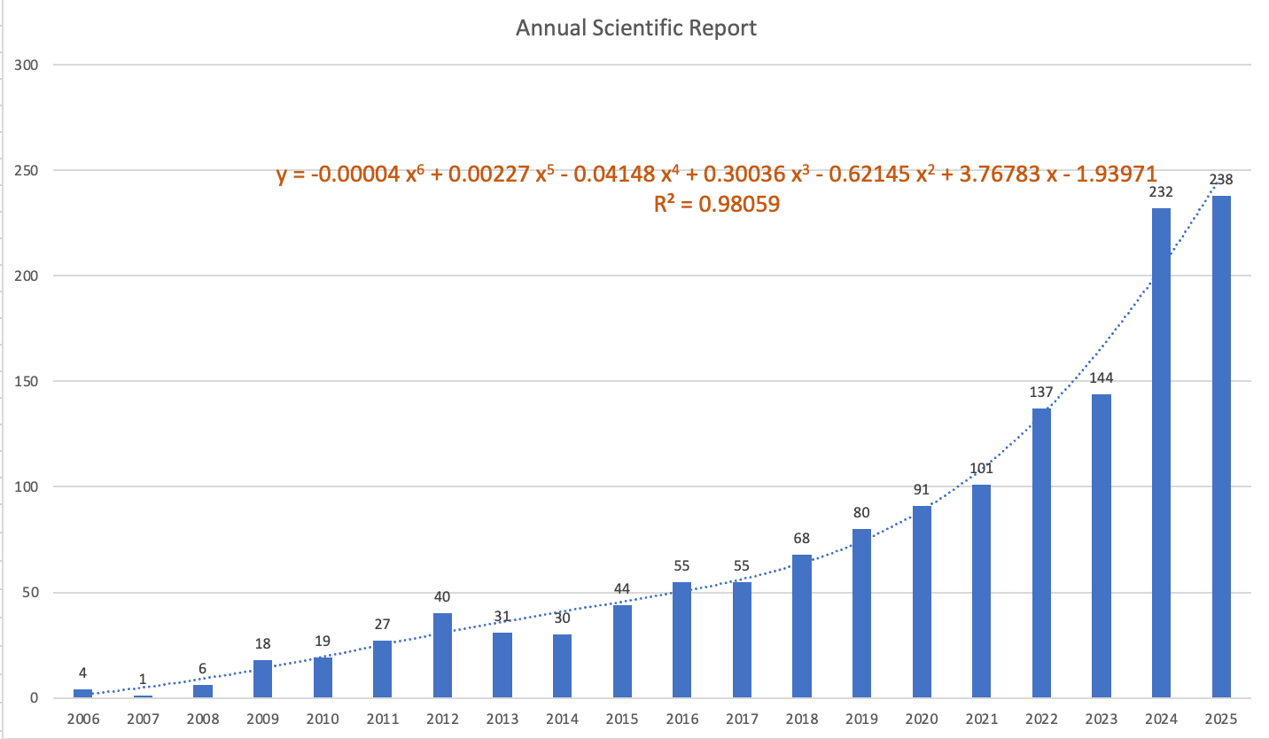
Figure 3. Annual scientific production

5.2 Most relevant sources
Figure 4 illustrates the top 20 academic sources that have published articles on DL, indicating the number of articles from each source. ‘Education and Information Technologies’ stood out as the most prominent platform with 141 articles, fostering scholarly discussions and knowledge development. The journal’s focus on the intersection of education and technology makes it a suitable venue for research on digital skills and competencies. It was followed by ‘Computers & Education’ with 69 articles and ‘Journal of Adolescent & Adult Literacy’ with 59 articles. Other notable sources such as ‘Interactive Learning Environments’, ‘Learning Media and Technology’, ‘British Journal of Educational Technology’ and ‘Literacy’ also contributed over 30 relevant articles.
The longitudinal publication trends across the 5 most relevant sources related to DL over 20 years (2006-2025) are shown in Figure 5. Overall, ‘Education and Information Technologies’ and Interactive Learning Environments’ experienced the most dramatic late surges, while ‘Computers & Education’ and the ‘Journal of Adolescent & Adult Literacy’ rose earlier but later stabilized. In contrast, ‘Learning Media and Technology’ showed only moderate and steady growth throughout the period.
In detail, ‘Education and Information Technologies’ remained at zero until 2018, after which its output expanded explosively, surpassing all others and reaching 141 by 2025. A similar but smaller pattern occurred in ‘Interactive Learning Environments’, which stayed inactive until 2016 before climbing to 45 in the final year. By comparison, ‘Computers & Education’ and ‘Journal of Adolescent & Adult Literacy’ both increased sharply in the earlier years. ‘Computers & Education’ rose from 1 in 2007 to 33 by 2019, but its pace slowed afterwards, ending at 69. ‘Journal of Adolescent & Adult Literacy’ followed a comparable path, levelling off at 59 in 2025. Unlike the others, ‘Learning Media and Technology’ never underwent a period of rapid expansion. Instead, it grew gradually from 2009 and remained the least dynamic journal, reaching only 38 by the end.

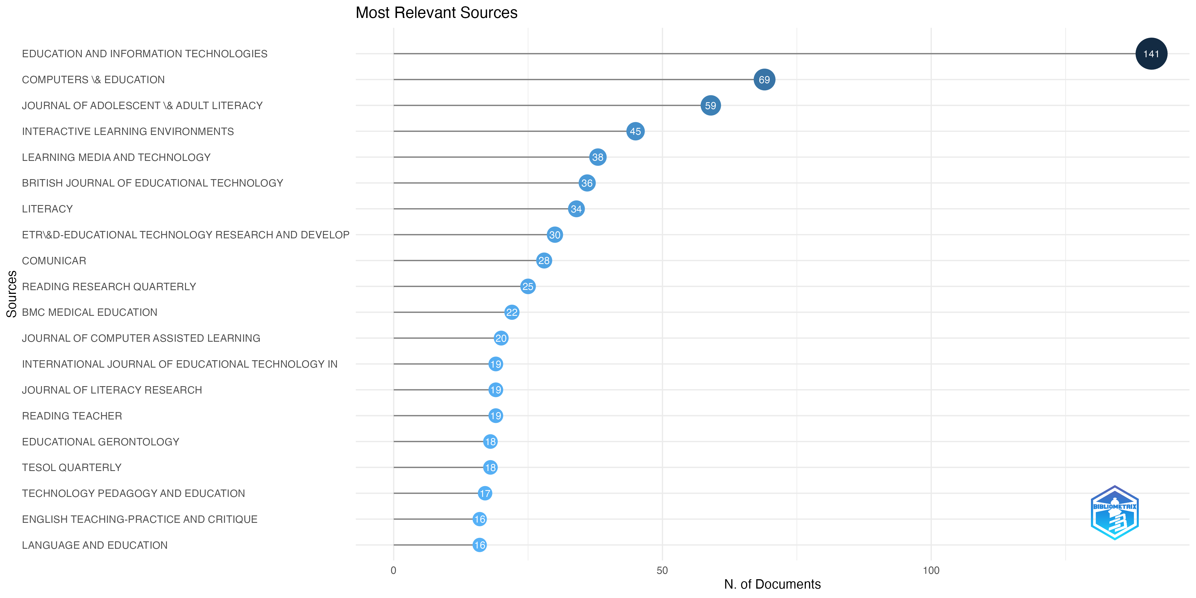
Figure 4. Most Relevant Sources
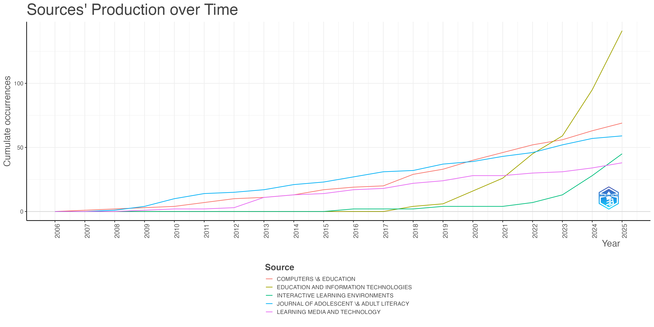
Figure 5. Sources’ Production over Time

5.3 Most relevant countries
Table 3 presents the top 10 countries with the highest number of publications in the field of DL in education. The United States contributed the most, with 981 articles, followed by the China (n=615), United Kingdom (n=379), Australia (n=344), and Spain (n=341). These five countries had publication volumes exceeding 340 articles. Figure 6 displays the annual publication trends of these top five countries. Overall, the United States remained the largest contributor, while China, despite entering later, recorded the most rapid acceleration. The UK and Australia demonstrated steady increases, and Spain also grew, but more moderately. Specifically, the USA rose from just 3 publications in 2006 to nearly 1,000 in 2025, far outpacing the UK, which increased from 2 to 379. Australia followed a similar trajectory but remained lower, reaching 344 in 2025. China, with no publications until 2011, expanded sharply after 2020, overtaking both Spain and Australia to reach 615 by 2025. Spain’s growth was steady, climbing from almost none in 2006 to 341, though it was surpassed by China in the later years.

Table 3. Countries’ Scientific Production
Country | Freq | Country | Freq
USA | 981 | Canada | 167
China | 615 | Germany | 100
UK | 379 | Norway | 98
Australia | 344 | Sweden | 94
Spain | 341 | South Korea | 91

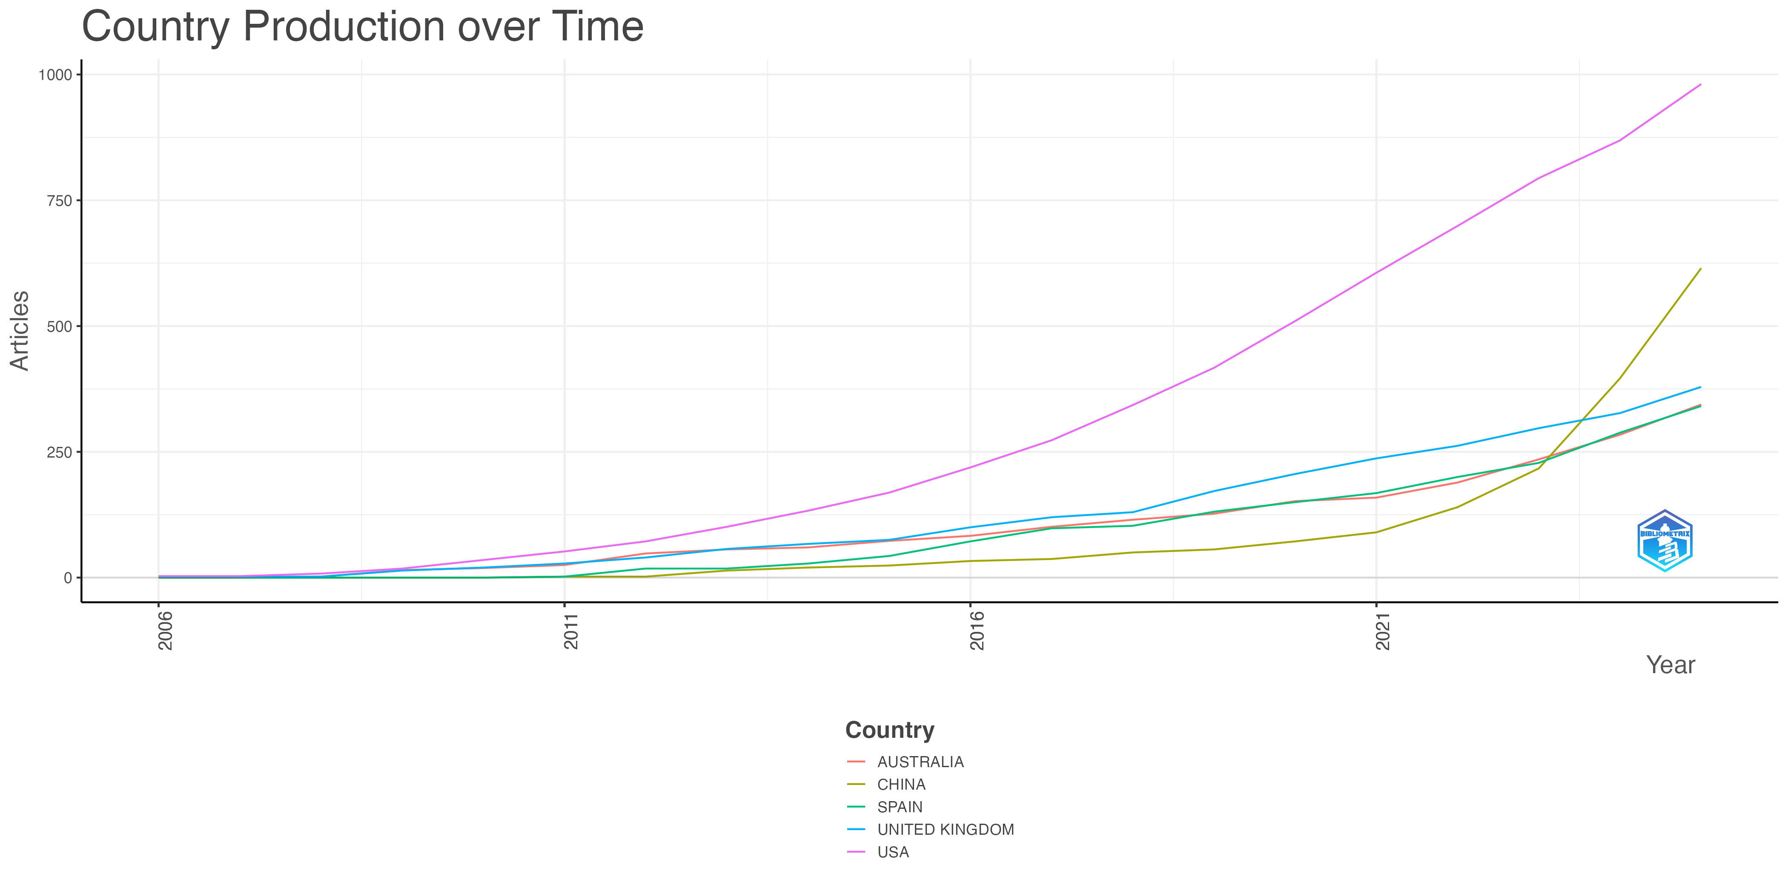
Figure 6. Country production over time

5.4 Latent topics and topic trends
Figure 7 presents the performance of different topic models in terms of perplexity and coherence across various topics, which identifies 12 as the optimal number of topics for extracting DL in education. In alignment with this finding, table 4 provides the results of LDA topic modeling predictions, including topic names, representative terms, and proportions for 12 identified topics. As a supplement, Figure 8 shows the trends of 12 topics every five years.
The representative terms in Table 4 provide a depiction of potential topics. Specifically, topic 1 (T1) encompasses pivotal concepts including ‘language’, ‘writing,’ ‘English,’ ‘multimodality,’ ‘culture,’ and ‘identity’. These terms signify a focus on the intersection of DL and language education, encompassing topics such as multimodal teaching, writing pedagogy, and cross-cultural identity considerations (e.g., Yu & Zadorozhnyy, 2021). Topic 2 (T2), characterized by terms including ‘academic,’ ‘test,’ ‘performance,’ ‘train,’ ‘attitude,’ ‘perception,’ and ‘motivation’ implies that this topic delves into the impact of DL on academic performance and student learning attitudes (e.g., Ibrahim & Aldawsari, 2023). Accordingly, this topic has been named ‘Academic Performance and Learner Perceptions’. Besides, representative terms, like ‘online,’ ‘environment,’ ‘resource,’ ‘provide,’ ‘support,’ etc., in topic 3 (T3) display that this topic is highly related to the exploration of different digital resources in the educational environment and whether they support student learning (e.g., Woods, 2020). Hence, this theme has been designated as ‘Exploration and Support of Educational Environment’. Topic 4 (T4) was titled ‘Education Policy’ in recognition of its topic focus on the intersection of DL with educational policies and challenges (e.g., Weninger, 2017), as evidenced by the inclusion of keywords such as ‘policy,’ ‘challenges,’ and ‘systems’. The terms such as ‘teachers,’ ‘teach,’ ‘development,’ ‘train,’ ‘pre-service,’ and ‘professional’ underscore that the 5th topic (T5) focuses on DL training and education for teachers (e.g., Palacios-Hidalgo & Huertas-Abril, 2022). Therefore, this theme is designated as ‘Teacher Education’. The presence of terms like ‘collaborative,’ ‘collaboration,’ ‘group,’ ‘activity,’ etc., suggests an emphasis on DL and collaborative learning approach (e.g., Sharp, 2017) within the 6th topic (T6), thus warranting its designation as ‘Collaborative Learning’. The 7th topic (T7) was considered as ‘Influencing Factors’ because the keywords include ‘relationship,’ ‘role,’ ‘influence,’ ‘factor,’ ‘model,’ etc., which suggests exploring the relationship between DL and other influencing factors (e.g., Zhang, 2023). In the 8th topic (T8), terms such as ‘social,’ ‘media,’ ‘product,’ and ‘tool’ suggest the link with social media. However, the concurrent inclusion of terms like ‘critical,’ ‘discuss,’ and ‘theories’ implies the incorporation of critical thinking within the realm of DL related to social media (e.g., Cheng et al., 2022). Therefore, this research theme is designated as ‘Social Media and Critical Thinking’. Additionally, the keywords ‘age,’ ‘adult,’ ‘university,’ and others highlight the focal point of the 9th topic (T9) revolves around the discussion of DL in adult education (e.g., Jimoyianni & Gravani, 2011). Correspondingly, in the 10th topic (T10), the words ‘children,’ ‘parents,’ ‘games,’ ‘young,’ and ‘earlier’ outline that the research on the development of children’s DL in family education is the focus of this theme (e.g., Kabakus et al., 2023). Consequently, this theme has been titled ‘Family Education and Child Development’ to encapsulate this emphasis. The 11th topic (T11), comprising keywords such as ‘assessment,’ ‘evaluation,’ ‘source,’ ‘instruction,’ ‘strategies,’ and ‘task,’ implies the involvement of assessing and enhancing DL through various strategies (e.g., Anthonysamy et al., 2020). As a result, the author proposes to name this theme ‘Assessment and Strategies’. In the 12th topic (T12), the representative terms ‘framework,’ ‘development,’ ‘research,’ ‘concept,’ ‘approach,’ and ‘question’ imply that the topic is related to the concept and framework of DL, validation, and other issues (e.g., Chang et al., 2023). Therefore, this topic is called ‘Concept and Framework’.
Finally, according to Table 4, the top five discussion topics of DL in the field of education are T1 (8.87%), T2 (8.41%), T3(8.40%), T4 (8.38%), and T5 (8.37%). Additionally, the Mann-Kendall test results indicate that only T11 exhibits a statistically significant increasing trend (p<0.05, Z=2.4982). In comparison, other topics did not show substantial upward or downward trends. However, several topics demonstrated an overall increasing trend, although not statistically significant (i.e., T2, T3, T4, T6, T7, T9, T12). Conversely, topics such as T1, T5, and T8 declined.

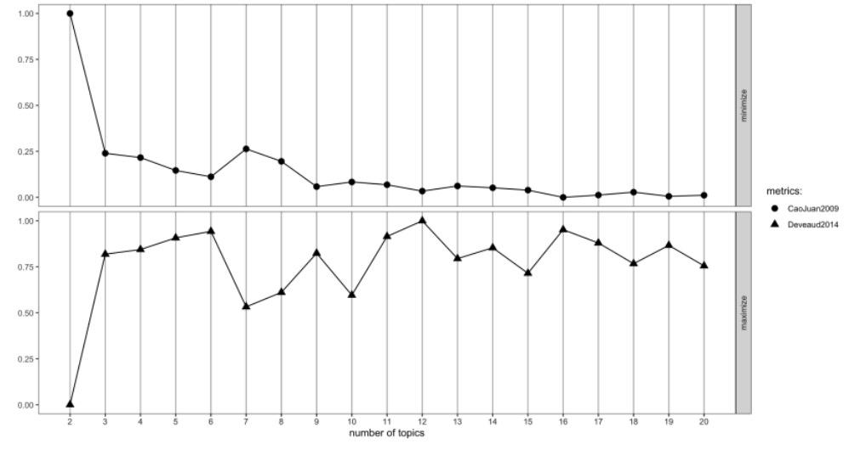
Figure 7. The performance of topic models with different numbers of topics in terms of perplexity and coherence

Table 4. Topic labels with their representative terms, proportions in the whole corpus
Topic Names | Representative Terms | Topic Proportion (%) | Mann-Kendall test
Topic Names | Representative Terms | Topic Proportion (%) | Z | p | S | Trend
Language Education  (T1) | Practice, language, write, article, multimodal, culture, space, English, youth, project, case, way, identity, communities, make | 8.87% | -1.6547 | 0.09799 | -52 | ↓
Academic Performance & Learner Perceptions  (T2) | Result, level, significance, show, performance, effect, academic, test, difference, high, attitude, perception, perceive, motivation, train | 8.41% | 1.8493 | 0.06441 | 58 | ↑
Exploration and Support of Educational Environment  (T3) | Learn, online, support, learner, engagement, environment, resource, enhance, find, explore, facilitate, provide, course, open, cognitive | 8.40% | 0.6818 | 0.4954 | 19 | ↑
Education Policy  (T4) | education, teach, higher, experience, universities, challenge, pandemic, policies, development, covid-19, include institution, focus, system, adopt | 8.38% | 0.292 | 0.7703 | 10 | ↑
Teacher Education  (T5) | Teacher, teach, development, education, profession, program, integrate, classroom, implement, pedagogy, train, tool, technology, pre-service teacher, strategies | 8.37% | -0.22711 | 0.8203 | -8 | ↓
Collaborative Learning  (T6) | Participants, activities, data, design, group, analysis, find, process, collaborative, quality, collaboration, interview, analyze, method, creativity | 8.26% | 1.7844 | 0.07435 | 56 | ↑
Influence Factors  (T7) | model, relation, factor, computer, position, important, program, relationship, role, influence, mediation, structure, result, aim | 8.24% | 1.1355 | 0.2561 | 36 | ↑
Social Media & Critical Thinking  (T8) | Social, media, critical, tool, context, discuss, person, article, product, issues, network pedagogy, offer, theories, recent | 8.23% | -1.8493 | 0.06441 | -58 | ↓
Adult Education  (T9) | Competency, communication, age, report, assessment, increase, university, survey, provide, internet, adult, future, mobile, present, support | 8.23% | 1.46 | 0.1443 | 46 | ↑
Family Education & Child  Development  (T10) | Children, practice, understand, text, young, explore, experience, author, play game, parent, year, engagement, home, earlier | 8.22% | 0.42178 | 0.6732 | 14 | ↑
Assessment & Strategies  (T11) | Information, knowledge, read, assessment, evaluation, instruction, ability, content, online, strategies, task, source, integrative, comprehensive, internet | 8.20% | 2.4982 | 0.01248 | 78 | ↑↑
Concept & Framework  (T12) | Paper, approach, framework, work, development, reflective, emergency, contribution, research, address, perspective, base, question, literature, concept | 8.17% | 1.2653 | 0.2058 | 40 | ↑
Note: full names of abbreviations (ict: information and communication technology). ↑ (↓) denotes a non-significant increasing (decreasing) trend (p > 0.05). ↑↑↑ (↓↓↓), ↑↑↑↑ (↓↓↓↓) indicate a significantly increasing (decreasing) trend with statistical significance at p < 0.05, p < 0.01, and p < 0.001, respectively.

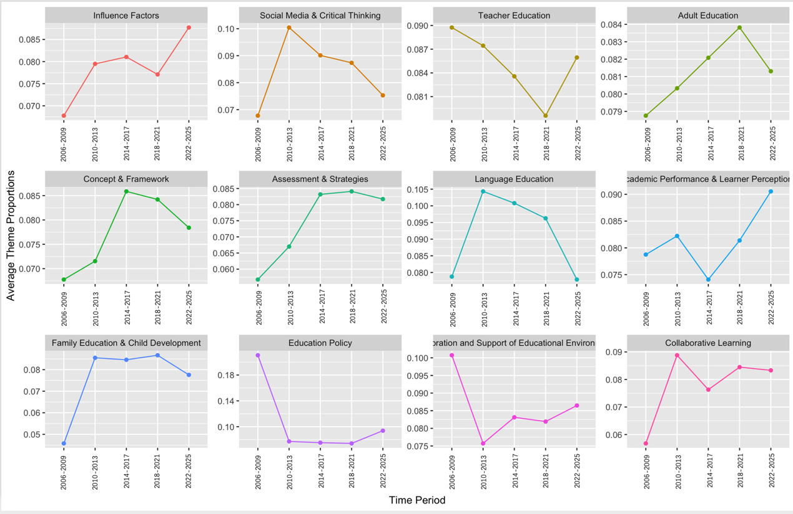
Figure 8. The trends of the 12 research topics

- Discussion and Implication
This study conducted a bibliometric review and topic modeling techniques to examine the literature on DL in education. By examining the current research landscape, this paper found a substantial increase in the number of publications on DL in education, which aligns with the findings of previous studies (e.g., Audrin & Audrin, 2022; Tinmaz et al., 2022). This finding provides evidence for the prominent position of DL within the field of education.
Regarding the most relevant sources, these findings are inconsistent with the review conducted by Audrin and Audrin (2022). In their review, they found that the journals with the highest number of publications at that time were ‘Computers & Education,’ followed by the ‘International Journal of Digital Literacy and Digital Competence,’ with 41 and 27 publications, respectively. In contrast, this study found that the journals with the highest number of publications to date were ‘Educational and Information Technologies’ and ‘Computers & Education,’ with 141 and 69 publications, respectively. This discrepancy can be attributed to differences in the search period, databases used, and keywords utilized between the studies. This research provides updated information on the relevant literature in the field of DL, which serves as a valuable resource for researchers in their literature searches and submission stages of research output.
Additionally, this paper has discussed contributing countries. Overall, the West has made a significant contribution in this area. This viewpoint is consistent with Gutiérrez-Ángel et al. (2022). However, what is different is that this paper has found that China's contribution to this field has made rapid progress in recent years, which may be due to the support of relevant policies. For example, since 2021, the Cyberspace Administration of China (2021) has issued the ‘Action Plan to Enhance Digital Literacy for the People’, which calls for enriching the supply of quality digital resources, improving the quality of digital lifestyles, enhancing efficient digital work capabilities, establishing a lifelong digital learning system, stimulating digital innovation, enhancing digital security protection, and strengthening the legal and ethical norms of the digital society. Subsequently, in 2023, the Chinese Ministry of Education advocated for promoting DL frameworks to foster digital talent, sparking increased attention from the educational community (Liu & Cen, 2024). However, it is worth noting that relatively limited research is conducted in developing countries. This can be attributed to their inadequate infrastructure, lack of economic support, and a shortage of relevant professional guidance (Reddy et al., 2021), which may contribute to the digital divide. Hence, the author advocates for cross-border collaboration in future DL education practices. For instance, developing countries can seek advanced educational technology resources from developed countries to improve their infrastructure and accelerate their digitization process. Additionally, developing countries can explore opportunities for collaboration with developed countries to establish digital skills training and education programs, providing necessary technical knowledge and capacity building for local teachers and students. Moreover, this also implies that future research could pay attention to the digital divide, digital equality, and DL. Although the digital divide can jeopardize the fair distribution of opportunities and respect for basic rights, this topic has only received sporadic discussion so far (Taddeo, 2020). Hence future research could explore more on the impact and challenges of the digital divide on DL, strategies to improve digital equality, and so on.
In addition, the author utilized topic modeling to identify 12 potential topics in DL: ‘Language Education (T1),’ ‘Academic Performance & Learner Perceptions (T2),’ ‘Exploration and Support of Educational Environment (T3),’ ‘Education Policy (T4),’ ‘Teacher Education (T5),’ ‘Collaborative Learning (T6),’ ‘Influence Factors (T7),’ ‘Social Media & Critical Thinking (T8),’ ‘Adult Education (T9),’ ‘Family Education & Child Development (T10),’ ‘Assessment & Strategies (T11),’ and ‘Concept & Framework (T12)’. However, these topic classifications were not neatly aligned with the previous topic classification (e.g., Audrin & Audrin, 2022; Tinmaz et al., 2022). The main reason for this is that scholars choose different databases and the analysis methods are also different.
In terms of topic distribution, firstly, from the ratio of total published articles, this study found that T1, T2, and T3 were the three topics with the highest proportion. This is mainly because, firstly, DL evolved from literacy, which is related to the emphasis on reading and writing ability. Although DL is constantly enriched in the later stage, its emphasis on reading and writing ability by using online sources (Bulger et al., 2014) is also its focus, which belongs to the research scope of language education. Therefore, T1 is the highest. Secondly, in education, academic performance and learner perceptions are two vital criteria for assessing learning outcomes. They are key focal points for educational practitioners. As a result, T2 has attracted a large number of scholars to conduct research, which can help scholars better understand the mechanisms underlying the interplay among these three. These results not only provide valuable guidance for instructional practices but also pave the way for the later development of well-established theories. Thirdly, the prominence of T3 in research findings can be attributed to the continuous advancement of digital technologies has led to the proliferation of electronic resources and various digital environments, thus generating a wealth of research opportunities, leading to a T3 account for a high proportion.
Regarding research trends, most topics (i.e., T2, T3, T4, T6, T7, T9, T11, T12) showed an upward trend, albeit not significantly. This indicates a growing overall interest in DL as a subject. In tandem, the results of Mann-Kendell present that the research on T11 showed the most prominent increase. However, T1, T5, T8 exhibited a declining trend. This indicates a promising future for research on DL, with T2, T3, T4, T6, T7, T9, T11, and T12 becoming rising topics in future research, but the most important focus may be on T11.
Specifically, the author observed a similar trend in research on T1 and T8, which grew from 2006-2009 until reaching its peak from 2010-2013. Between 2010 and 2021, these two topics consistently remained the most popular, despite a slight decline in the following 13 years (2013-2025). Moreover, during 2010-2021, T1 (10.43% in 2010-2013, 10.08% in 2014-2017, 9.63% in 2018-2021) and T8(10.05% in 2010-2013, 9.01% in 2014-2017, and 8.74% in 2018-2021) have always been the most discussed topics. The reason why T1 has become the most discussed topic has been previously mentioned, while the popularity of T8 is mainly attributed to the rise of social media. Since the establishment of Facebook around 2005, a series of social media platforms such as Twitter, YouTube, and so on (Hayden & Tomal, 2024). Although these platforms have promoted communication, they have also brought a series of problems, such as false information, ethical issues, etc. Hence, scholars have begun to think about how to improve critical thinking in DL to resist these problems (Kellner & Share, 2005).
Additionally, the trends for T11 and T12 show similarities. Both topics experienced continuous growth from 2006-2009, peaked from 2014 to 2017, and then experienced a slight decline until 2025. This is mainly because there is a strong correlation between these two topics. Put differently, the assessment of DL helps to form concepts and frameworks, and the formation of related concepts requires a large amount of assessment to verify, which in turn generates relevant concepts and strategic exploration. This discovery is similar to that of Spante et al.’s (2018) review, which suggests that since 2010, there has been a surge in research related to the concept of DL. The emergence of this phenomenon can be attributed to the support from international educational institutions. For instance, the European Commission introduced the DigComp Framework in 2013 (Kassim et al., 2013). In tandem, ‘The Shape of the Australian Curriculum (Version 4.0)’ released by the Australian government in 2012 proposes the constituent elements related to ICT literacy.
On the other hand, T5 shows an opposite trend to that of T9. Specifically, from 2006 to 2021, T5 gradually declined, reaching a low point in 2018-2021. From 2022 to 2025, the popularity of T5 has rebounded. However, the trend of T9 is exactly the opposite. This has displayed the shift in the focus of academic research on DL, namely, prior to the pandemic, academics placed more emphasis on learners vis-à-vis teachers, and this phenomenon reversed during the pandemic. There are two possible reasons behind this. The first is the need for reality, that is, after the widespread online learning during the pandemic, researchers began to realize that teachers are no longer merely instructors responsible for teaching their students DL but also become learners themselves, constantly striving to enhance their DL in the wave of digital teaching. This phenomenon has attracted the attention of scholars. In addition, some policies and funding related to teachers’ DL have also emerged during this stage. For example, the Chinese Ministry of Education (2024) released "Digital Literacy for Teachers" during this stage, while the City University of New York has invested $14 million in a program called ‘Computing Integrated Teacher Education’ which aims to provide relevant DL training for current and future New York public school teachers (City University of New York, 2024). However, these two cases come from China and the United States, respectively, and further exploration is needed in the future as to why there is such a research trend in T9 and T5.
T4 and T3 were the two most focused topics in the early stages of research (2006-2009), accounting for 21.06% and 10.08% respectively. This result is plausible. Because in this early stage (2006-2009), as Lankshear et al. (2003) claimed, the intersection between DL practice and new technologies has been widely discussed, which means that exploration related to T3 has already begun. However, during this period, education policies were significantly lagging. One clue is that ‘Government policies often failed to reflect these insights and understandings in DL, learning, and technology’ (Snyder, 1999 p.1), which implies that T4 receives attention from scholars. However, both topics declined during 2010-2013, partly because there were fewer studies and topics in the earlier studies (2006-2009). However, at this stage, other topics also began to join, dispersing the proportion of these two. However, the difference was that during the 2014-2017 period, T3 began to rebound, and this rising trend persisted until 2025. The main reason for this phenomenon is the continuous development of digital technology, which has created many environments and resources for DL. For example, the rise of MOOC, AR, VR, and AI-assisted learning environments has created a good platform for the research of T3. While T4 experienced a slight decline before rebounding in the 2022–2025 period, this recovery can be largely attributed to the widespread adoption of online education after the pandemic and the rapid development of Web 3.0 technologies (e.g., Metaverse AI-enhanced learning agents, and immersive XR tools) has developed rapidly during this period (e.g., Author et al., 2023), bringing new education opportunities but also raising ethical issues, providing policymakers with a unique opportunity to reconsider the formulation of education policies.
Similar to most of the studies, T2, T6, T7, and T10 showed a level of growth from 2006-2009 to 2010-2013, indicating that the academic community began to pay attention to these. By 2014-2017, only T7 was still on a slight rise, but the other three were in decline. As mentioned earlier, the focus of research at this stage has shifted to T11 and T12, dispersing the focus on these research topics. Interestingly, by 2018-2021, the trend was reversed. To the best knowledge, these patterns have not been explored by previous literature; hence, the reasons underlying them need to be verified. By 2022-2025, T6 and T10 are decreasing, while T2 and T7 are increasing. Epidemics may partly account for this phenomenon. In particular, similar to other research areas, T2 and T7 experienced significant growth owing to the rapid expansion of online education during the pandemic. Importantly, these topics have continued to attract scholarly attention even in the post-pandemic period, thereby contributing to the sustained increase in research on T2 and T7. One result related to T7 is that Gutiérrez-Ángel et al.’s (2022) review revealed that, through a comparison of research before and after the epidemic there has been an expansion of the topics and variables that are studied in conjunction with DL, which confirms the pattern. By contrast, T6 and T10, which require data involving children, families, and collaborative tasks, experienced a temporary decline. This is likely due to the limited accessibility of on-site learning environments during and shortly after the pandemic, which constrained researchers’ ability to conduct direct observations and collect the necessary data for these topics. Consequently, although interest in T6 and T10 remains, practical challenges temporarily hindered their study.
These research distributions, trends, and reasonable reasons also provide insights for researchers, educators, and education policymakers. Specifically, for researchers, this study used topic modeling to help them understand the hot topics in the field of DL education, providing a reference for their future research direction. In addition, this also indicates that some topics are not well-researched, such as art education, vocational education, special education, and STEM (science, technology, engineering, mathematics) education. Therefore, future researchers can attempt in these fields. Secondly, the topic distribution also displays that regarding the sample selection, most studies are conducted in campus environments and targeted at the general population (particularly university students). In future research, more perspectives can be placed on other populations (e.g., business professionals, older adults, etc.). In addition, the reasons behind some of the research trends revealed in this article also urgently need to be discussed and verified by researchers in the future. Besides, there is an urgent need for researchers to propose some unique insights in the context of the new era. For example, with the emergence of AI technology, how should DL be interpreted in the AI era to assist teachers and students in understanding AI systems, interpreting their outputs, and responsibly leveraging AI tools is waiting to be answered.
These research distributions also provide some insights for educators to integrate DL into educational practice. Overall, the practice of DL runs through the entire teaching process. During the instructional design and preparation phase (T1, T4, T5, T12), teachers can choose and integrate suitable digital tools and resources, such as online dictionaries and language learning applications, and incorporate these tools into their teaching plans to ensure that students fully utilize digital resources in their learning. Secondly, teachers should understand and follow the teaching policies of the school and education department regarding DL, and design courses that comply with DL requirements according to policy requirements. In addition, teachers need to participate in relevant digital literacy training in advance, continuously improve their DL through online learning and peer communication, and prepare for the effective use of digital technology in the classroom. Finally, teachers should clarify the concept of DL in curriculum design and integrate it into the teaching syllabus to ensure the organic integration of digital skills and subject content. During the teaching implementation process (T2, T3, T6, T8), teachers can use relevant learning management systems and online assessment tools to monitor students' academic performance in real-time in the classroom, to adjust teaching strategies promptly to meet the learning needs of different students. Secondly, teachers can utilize new educational environments such as virtual teachers, online discussion boards, and collaboration platforms to encourage students to engage in independent or collaborative exploration and enhance their communication and collaboration skills. In addition, teachers can cultivate students' critical thinking when using social media through practical cases or tasks during the teaching process, which can help the students analyze the authenticity and information sources of social media content in classroom discussions, thereby improving their digital thinking skills. In the stages of teaching evaluation and reflection (T7, T9, T10, T11), teachers should assess students' learning outcomes and analyze different factors that affect the development of DL, such as students' socio-economic background and opportunities for technological acquisition, to make improvements in subsequent teaching. And provide targeted support by giving different feedback based on students' different learning stages (e.g., adult education, children's education). Finally, teachers can use online assessment tools to collect students' learning data and reflect on and adjust teaching strategies based on this data to better support students' DL development.

- Conclusion
DL has become a key skill that urgently needs to be cultivated in the era of rapidly changing technology and diverse talent demands. Hence, this study used bibliometric analysis to investigate 1,421 educational research articles related to DL published in the WoS from January 2006 to August 2025. This review covers annual publications, relevant sources, countries, research topics, and trends, which have theoretical and practical significance. Theoretically, this study made a scientific contribution in two aspects. Firstly, it provided an overall research status of DL in education. Secondly, it depicts 12 latent topics that did not precisely align with those identified in previous studies on DL (e.g., Audrin & Audrin, 2022; Tinmaz et al., 2022). Practically, the study discussed the reasonable reasons for these different trends, estimated the popular directions for future research, and proposed relevant implications based on these results, which guided further studies and practices for DL research. However, this review also has some limitations. Firstly, in the topic modeling section, the author only considered the abstract part as the research object. While this approach is commonly used to examine research trends (e.g., Tinmaz et al., 2022), it overlooks valuable information present in other sections, such as findings and conclusions. Secondly, since topic modeling is an unsupervised algorithm and the naming of topics is based on the most frequently occurring words and articles closely associated with each topic, while this approach allows for the validation of the chosen topic names, different researchers may annotate the same data differently. For these reasons, future research may include the entire article for review and researchers can manually annotate the topic to ensure accuracy and consistency.

Funding
This research received no specific grant from any funding agency, commercial or not-for-profit sectors.

Acknowledgment
The author thanks the editors and the reviewers for their useful feedback that improved this paper.

References
- Author et al. (2023) blind for review
- American Library Association. (2017). Welcome to ALA’s literacy clearinghouse: Digital literacy. Available at: https://literacy.ala.org/digital-literacy/ (Accessed: 24 May 2024).
- Anthonysamy, L., Koo, A.C. and Hew, S.H. (2020). Self-regulated learning strategies in higher education: Fostering digital literacy for sustainable lifelong learning. Education and Information Technologies, 25, pp.239–251. https://doi.org/10.1007/s10639-020-10201-8
- Aria, M. and Cuccurullo, C. (2017). Bibliometrix: An R-tool for comprehensive science mapping analysis. Journal of Informetrics, 11(4), pp.959–975. https://doi.org/10.1016/j.joi.2017.08.007
- Audrin, C. and Audrin, B. (2022). Key factors in digital literacy in learning and education: A systematic literature review using text mining. Education and Information Technologies, 27, pp.2321–2345. https://doi.org/10.1007/s10639-021-10832-5
- Australian Curriculum, Assessment and Reporting Authority. (2010). The shape of the Australian curriculum (Version 4.0) [Online]. Available at: https://www.acara.edu.au/curriculum (Accessed: 24 May 2024).
- Blei, D.M., Ng, A.Y. and Jordan, M.I. (2003). Latent Dirichlet Allocation. Journal of Machine Learning Research, 3, pp.993–1022.
- Bulger, M.E., Mayer, R.E. and Metzger, M.J. (2014). Knowledge and processes that predict proficiency in digital literacy. Reading and Writing, 27, pp.1567–1583. https://doi.org/10.1007/s11145-014-9507-2
- Cao, J., Xia, T., Li, J., Zhang, Y. and Tang, S. (2009). A density-based method for adaptive LDA model selection. Neurocomputing, 72(7–9), pp.1775–1781. https://doi.org/10.1016/j.neucom.2008.06.011
- Central Cybersecurity and Information Technology Commission. (2021). The Central Cybersecurity and Information Technology Commission issues the "Action Plan for Enhancing Digital Literacy and Skills of the People" [Online]. Available at: http://www.cac.gov.cn/2021-11/05/c_1637708867331677.htm (Accessed: 24 May 2024).
- Chang, C.Y., Kuo, H.C. and Du, Z. (2023). The role of digital literacy in augmented, virtual, and mixed reality in popular science education: A review study and an educational framework development. Virtual Reality, 27(1), pp.83–100. https://doi.org/10.1007/s10055-023-00817-9
- Chen, X.L., Zou, D. and Xie, H.R. (2020). Fifty years of British Journal of Educational Technology: A topic modeling-based bibliometric perspective. British Journal of Educational Technology, 51(3), pp.692–708. https://doi.org/10.1111/bjet.12907
- Cheng, L., Fang, G., Zhang, X. and Lv, Y. (2022). Impact of social media use on critical thinking ability of university students. Library Hi Tech [Online]. https://doi.org/10.1108/LHT-11-2021-0393
- Chetty, K., Qigui, L., Gcora, N., Josie, J., Wenwei, L. and Fang, C. (2018). Bridging the digital divide: Measuring digital literacy. Economics: The Open-Access, Open-Assessment E-Journal, 12(2018-23). https://doi.org/10.5018/economics-ejournal.ja.2018-23
- City University of New York. (2024). Computing integrated teacher education. Available at: https://www.cuny.edu/academics/academic-programs/teacher-education- (Accessed: 24 May 2024).
- Deveaud, R., SanJuan, E. and Bellot, P. (2014). Accurate and effective latent concept modeling for ad hoc information retrieval. Document Numérique, 17(1), pp.61–84. https://doi.org/10.3166/dn.17.1.61-84
- Eshet, Y. (2002). Digital literacy: A new terminology framework and its application to the design of meaningful technology-based learning environments. In: EdMedia: World Conference on Educational Media and Technology. Vol. 1, pp.493–498.
- Eshet, Y. (2004). Digital literacy: A conceptual framework for survival skills in the digital era. Journal of Educational Multimedia and Hypermedia, 13(1), pp.93–106.
- Fraillon, J., Ainley, J., Schulz, W., Duckworth, D. and Friedman, T. (2019). IEA international computer and information literacy study 2018 assessment framework. Springer International Publishing.
- Gilster, P. (1997). Digital literacy. Wiley.
- Gutiérrez-Ángel, N., Sánchez-García, J.N., Mercader-Rubio, I., García-Martín, J. and Brito-Costa, S. (2022). Digital literacy in the university setting: A literature review of empirical studies between 2010 and 2021. Frontiers in Psychology, 13, 896800. https://doi.org/10.3389/fpsyg.2022.896800
- Hayden, B. and Tomal, R. (2024). A history of social media. Available at: https://copyblogger.com/history-of-social-media/ (Accessed: 24 May 2024).
- Jelodar, H., Wang, Y., Yuan, C., Feng, X., Jiang, X., Li, Y. and Zhao, L. (2018). Latent Dirichlet Allocation (LDA) and topic modeling: Models, applications, a survey. Multimedia Tools and Applications, 78(11), pp.15169–15211. https://doi.org/10.1007/s11042-018-6894-4
- Jimoyianni, A. and Gravani, M. (2011). Exploring adult digital literacy using learners’ and educators’ perceptions and experiences: The case of the second chance schools in Greece. Journal of Educational Technology & Society, 14(1), pp.217–227.
- Kabakus, A., Bahcekapili, E. and Ayaz, A. (2023). The effect of digital literacy on technology acceptance: An evaluation on administrative staff in higher education. Journal of Information Science. https://doi.org/10.1177/01655515231160028
- Kassim, H., Peterson, J., Bauer, M.W., Connolly, S., Dehousse, R., Hooghe, L. and Thompson, A. (2013). The European Commission of the twenty-first century. Oxford University Press.
- Kellner, D. and Share, J. (2005). Toward critical media literacy: Core concepts, debates, organizations, and policy. Discourse: Studies in the Cultural Politics of Education, 26(3), pp.369–386. https://doi.org/10.1080/01596300500200169
- Lankshear, C. and Knobel, M. (2003). New literacies: Changing knowledge and classroom learning. Open University Press.
- Law, N., Woo, D., de la Torre, J. and Wong, G. (2018). A global framework of reference on digital literacy skills for indicator 4.4.2 [Online]. UNESCO. Available at: https://uis.unesco.org/sites/default/files/documents/ip51-global-framework-reference-digital-literacy-skills-2018-en.pdf (Accessed: 24 May 2024).
- Liu, B. and Cen, Y. (2024). Promoting digital talent training through digital literacy framework [Online]. Government Portal Website Ministry of Education, People’s Republic of China. Available at: http://www.moe.gov.cn/jyb_xwfb/xw_zt/moe_357/2023/2023_zt01/mtbd/202302/t20230227_1047949.html (Accessed: 24 May 2024).
- Liu, C., Zou, D., Chen, X., Xie, H. and Chan, W.H. (2021). A bibliometric review on latent topics and trends of the empirical MOOC literature (2008–2019). Asia Pacific Education Review, 22(4), pp.515–534. https://doi.org/10.1007/s12564-021-09692-y
- Martínez-Bravo, M.C., Sádaba, C.C. and Serrano, P.J. (2022). Dimensions of digital literacy in the 21st century competency frameworks. Sustainability, 14(3), 1867. https://doi.org/10.3390/su14031867
- Meyers, E.M., Erickson, I. and Small, R.V. (2013). Digital literacy and informal learning environments: An introduction. Learning, Media and Technology, 38(4), pp.355–367. https://doi.org/10.1080/17439884.2013.783597
- Ministry of Education. (2024). Notice of the Ministry of Education on issuing the education industry standards for teacher digital literacy [Online]. Available at: http://www.moe.gov.cn/srcsite/A16/s3342/202302/t20230214_1044634.html (Accessed: 24 May 2024).
- Ng, W. (2012). Can we teach digital natives’ digital literacy? Computers & Education, 59(3), pp.1065–1078. https://doi.org/10.1016/j.compedu.2012.04.016
- Nikita, M. (2024). Package “ldatuning” (Version 1.0.2) [Software]. CRAN. Available at: https://cran.r-project.org/web/packages/ldatuning/index.html (Accessed: 24 May 2024).
- Palacios-Hidalgo, F.J. and Huertas-Abril, C.A. (2022). Developing digital literacy in initial EFL teacher education: A study in a Spanish distance university. Open Learning: The Journal of Open, Distance and e-Learning. https://doi.org/10.1080/02680513.2022.2157709
- Pangrazio, L., Godhe, A.L. and Ledesma, A.G.L. (2020). What is digital literacy? A comparative review of publications across three language contexts. E-Learning and Digital Media, 17(5), pp.442–459. https://doi.org/10.1177/2042753020946291
- Pritchard, A. (1969). Statistical bibliography or bibliometrics. Journal of Documentation, 25(4), pp.348–349.
- Reddy, P., Sharma, B. and Chaudhary, K. (2021). Digital literacy: A review in the South Pacific. Journal of Computing in Higher Education, 34, pp.83–108. https://doi.org/10.1007/s12528-021-09280-4
- Sharp, L.A. (2017). Enhancing digital literacy and learning among adults with blogs. Journal of Adolescent & Adult Literacy, 61(2), pp.191–202. https://doi.org/10.1002/jaal.675
- Snyder, I. (1999). Packaging literacy, new technologies and “enhanced” learning. Australian Journal of Education, 43(3), pp.285–299. https://doi.org/10.1177/000494419904300306
- Spante, M., Sofkova Hashemi, S., Lundin, M. and Algers, A. (2018). Digital competence and digital literacy in higher education research: Systematic review of concept use. Cogent Education, 5(1), 1519143. https://doi.org/10.1080/2331186X.2018.1519143
- Taddeo, M. (2020). The ethical governance of the digital during and after the COVID-19 pandemic. Minds and Machines, 30(2), pp.171–176. https://doi.org/10.1007/s11023-020-09528-5
- Tinmaz, H., Lee, Y.T., Fanea-Ivanovici, M. and Baber, H. (2022). A systematic review on digital literacy. Smart Learning Environments, 9(1), 4. https://doi.org/10.1186/s40561-022-00204-y
- Trilling, B. and Fadel, C. (2009). 21st century skills: Learning for life in our times. John Wiley & Sons.
- Tuamsuk, K. and Subramaniam, M. (2017). The current state and influential factors in the development of digital literacy in Thailand’s higher education. Information and Learning Sciences, 118(5/6), pp.235–251. https://doi.org/10.1108/ILS-11-2016-0076
- Weninger, C. (2017). The “vernacularization” of global education policy: Media and digital literacy as twenty-first-century skills in Singapore. Asia Pacific Journal of Education, 37(4), pp.500–516. https://doi.org/10.1080/02188791.2017.1336429
- Weninger, C. (2023). Digital literacy as ideological practice. ELT Journal, 77(2), pp.197–206. https://doi.org/10.1093/elt/ccad001
- Woods, K. (2020). The development and design of an interactive digital training resource for personal tutors. Frontiers in Education, 5, 100. https://doi.org/10.3389/feduc.2020.00100
- Yin, B. and Yuan, C.H. (2022). Detecting latent topics and trends in blended learning using LDA topic modeling. Education and Information Technologies, 28, pp.1–27. https://doi.org/10.1007/s10639-022-11118-0
- Zhang, J. (2023). EFL teachers’ digital literacy: The role of contextual factors in their literacy development. Frontiers in Psychology, 14, 1153339. https://doi.org/10.3389/fpsyg.2023.1153339

