Humanizing Heritage: AI-Driven First-Person Narrative and Cross-Cultural Communication of Canal Cultural Relics

Miao Chen^{1*}, Huan Cao¹, Ping Liu¹, Mengdi Guo¹, Panpan Qin¹, Chenyu Liu¹, Xinran Wu¹
¹ School of English, Zhejiang Yuexiu University of Foreign Languages, Shaoxing, Zhejiang 312000
Corresponding author: Huan Cao, E-mail: 201120138@zyufl.edu.cn

ABSTRACT
The digital transformation of cultural heritage has entered a new era where artificial intelligence enables unprecedented forms of engagement between historical artifacts and global audiences. This study explores the application of human-centric AI in revitalizing the Zhejiang Eastern Canal cultural relics through first-person narrative strategies and multilingual international communication. Drawing upon a multimodal bilingual database encompassing forty-two catalogued artifacts across five categories including bridges, architecture, steles, cultural heritage sites, and vessels, this research examines how AI-driven anthropomorphic storytelling can transcend traditional museological presentation modes. The project employs six United Nations official languages which are Chinese, English, French, Spanish, Russian, and Arabic alongside the local Shaoxing dialect to construct culturally adaptive narrative frameworks. By positioning artifacts as autonomous storytelling agents rather than passive exhibition objects, this approach fosters emotional resonance and cross-cultural understanding. The findings demonstrate that human-centric AI applications in heritage communication not only enhance international accessibility but also reconfigure the power dynamics between cultural preservation and technological innovation, offering a replicable model for regional heritage globalization. This study contributes to the emerging discourse on ethical AI deployment in cultural diplomacy and sustainable heritage futures.

Keywords: cultural heritage digitization; first-person narrative; cross-cultural communication; Zhejiang Eastern Canal; multilingual storytelling

1. Introduction

1.1 The Convergence of AI and Cultural Heritage Preservation
The convergence of artificial intelligence and cultural heritage preservation represents one of the most transformative developments in contemporary museology and international cultural relations. As globalization intensifies cultural exchanges while simultaneously threatening local heritage distinctiveness, the imperative to develop innovative communication strategies has become paramount. The Grand Canal of China, inscribed on the UNESCO World Heritage List in 2014, exemplifies this tension between universal value recognition and localized meaning preservation. Within this vast hydraulic system, the Zhejiang Eastern Canal section particularly its Shaoxing segment constitutes a critical yet underrepresented node of cultural significance that demands urgent scholarly attention and innovative preservation approaches.
The Zhejiang Eastern Canal, historically functioning as a vital economic artery connecting the Yangtze River Delta with maritime trade networks, has accumulated a rich material culture spanning over two millennia of continuous human activity. However, unlike the more prominent Beijing-Hangzhou Grand Canal sections that have received substantial international attention and academic scrutiny, this regional heritage has remained relatively obscure in both scholarly literature and international public awareness. Traditional preservation approaches have predominantly focused on physical conservation and domestic tourism development, neglecting the transformative potential of digital technologies to facilitate genuine global cultural dialogue and cross-border understanding.

1.2 The Human-Centric AI Imperative
The concept of human-centric AI has emerged as a necessary corrective to technology-driven approaches that prioritize computational efficiency over human flourishing and cultural sensitivity. As articulated in recent European Union policy frameworks and UNESCO digital heritage guidelines, human-centric AI emphasizes systems designed to augment human capabilities, respect cultural diversity, and promote inclusive participation rather than replacing human judgment with algorithmic determination.^{[1]} In the context of cultural heritage, this paradigm shift necessitates reimagining AI not merely as a tool for documentation and analysis, but as a medium for empathetic engagement and cross-cultural meaning-making that bridges historical temporalities and geographical distances.
The application of human-centric AI to cultural heritage communication presents unique opportunities alongside significant challenges that require careful theoretical and practical navigation. Unlike conventional digital humanities projects that treat AI as a passive infrastructure for information storage and retrieval, human-centric approaches position AI as an active participant in co-creating cultural narratives and facilitating interpretive encounters. This involves developing AI systems that can adapt to diverse cultural contexts, recognize and respond to emotional cues, and facilitate genuine dialogue between heritage artifacts and contemporary audiences across linguistic and cultural boundaries.

1.3 Research Objectives and Questions
This study investigates the design, implementation, and preliminary outcomes of a human-centric AI project focused on the Zhejiang Eastern Canal cultural relics, addressing three primary research questions that guide the analytical framework. First, the research examines how first-person narrative strategies enabled by AI technologies can transform audience engagement with regional cultural heritage, moving beyond passive consumption to active emotional and intellectual participation. Second, the study explores the linguistic and cultural challenges in developing multilingual storytelling frameworks for canal artifacts, and how human-centric design principles can address these challenges through adaptive translation and culturally sensitive presentation. Third, the research investigates the extent to which anthropomorphizing cultural relics through AI narration enhances international accessibility while maintaining historical authenticity and cultural sensitivity, avoiding the pitfalls of exoticization or oversimplification.

1.4 Structure of the Paper
The remainder of this paper is organized into six sections following this introduction. The literature review section surveys relevant scholarship on AI in cultural heritage, narrative theory in museology, and cross-cultural communication strategies, establishing the theoretical foundations for the research. The methodology section details the research design, database construction, narrative development process, multilingual implementation strategies, and digital platform architecture. The findings section presents analytical results regarding narrative transformation, multilingual challenges, ethical considerations, and cross-cultural reception patterns.
The discussion section examines implications for human-centric AI development and cultural heritage policy, while the conclusion reflects on limitations and future research directions.

2. Literature Review

2.1 Evolution of AI Applications in Cultural Heritage
The integration of artificial intelligence into cultural heritage practice has evolved through distinct phases that reflect broader shifts in digital humanities and museum studies. Initial applications focused primarily on computational analysis including image recognition for artifact classification, natural language processing for archival digitization, and predictive modeling for conservation planning.^{[7]} While these applications enhanced institutional efficiency and processing capabilities, they maintained a clear separation between technological infrastructure and cultural content, treating AI as a backend tool rather than a frontend medium for public engagement.
Recent scholarship has increasingly emphasized AI’s potential for public engagement and educational innovation in heritage contexts, moving beyond institutional efficiency toward audience transformation.^{[6]} The British Museum’s History of the World in 100 Objects project, though predating advanced AI technologies, established important precedents for narrative-driven heritage communication that prioritizes storytelling over cataloguing.^{[1]} More contemporary initiatives such as the Palace Museum’s Douyin Cloud Museum collaboration and the Dunhuang Research Institute’s animated drama series demonstrate the effectiveness of digitally mediated storytelling in reaching diverse domestic and international audiences, though these projects have received limited critical assessment regarding their cross-cultural efficacy and ethical implications.^{[8]}
Critical assessments of AI-enhanced heritage initiatives reveal persistent limitations that human-centric approaches must address. Many projects remain essentially didactic in nature, using technology to deliver pre-determined content rather than enabling genuine interaction or co-creation between audiences and heritage materials.^{[9]} The concept of digital heritage as articulated by UNESCO emphasizing participatory creation, cultural diversity, and sustainable access remains inadequately realized in practice, with most implementations prioritizing technological spectacle over meaningful cultural dialogue.

2.2 Narrative Theory and Museological Practice
The narrative turn in museum studies has fundamentally challenged traditional object-centered exhibition paradigms that treat artifacts as silent objects awaiting expert interpretation. Scholars such as Harrison and Simon have argued that effective heritage communication requires storytelling frameworks that connect historical artifacts to contemporary human experiences and emotional lives. This perspective aligns with broader phenomenological approaches that emphasize the embodied, emotional dimensions of cultural encounter rather than purely cognitive information transfer.^{[2]} First-person narration represents a particularly powerful yet underutilized strategy in heritage interpretation, as attributing voice and agency to historical artifacts can disrupt conventional temporal hierarchies and foster empathetic engagement across historical distance.^{[8]}
However, first-person narrative approaches raise complex questions about authenticity, appropriation, and the ethics of speaking for silent objects that have no literal capacity for speech. The development of AI-generated first-person narratives introduces additional layers of complexity regarding authorship, representation, and technological mediation that require careful ethical consideration.^{[3]} Questions of who speaks for the artifact, whose perspective is represented, and how multiple possible interpretations are negotiated become particularly acute when AI systems generate narrative content that may be perceived as authoritative or objective.

2.3 Multilingualism and Cultural Translation in Heritage Communication
The challenge of communicating cultural heritage across linguistic boundaries extends beyond literal translation to encompass what Appadurai terms the production of locality in global contexts. Cultural concepts embedded in heritage artifacts whether architectural terminology, religious symbolism, or social practices often resist direct linguistic transfer due to their embeddedness in specific historical and cultural systems of meaning.^{[7]} Effective multilingual heritage communication requires what Bhabha describes as cultural translation, a process of negotiation that preserves difference while enabling understanding, rather than assimilating foreign concepts into domestic frameworks.^{[10]}
Existing approaches to multilingual heritage communication have predominantly relied on professional translation services, resulting in standardized, institutionally authorized interpretations that may flatten cultural particularity.^{[4]} The emergence of AI translation technologies including neural machine translation and culturally specialized APIs offers possibilities for more dynamic, context-sensitive linguistic adaptation that can respond to user needs and cultural backgrounds. However, concerns regarding accuracy, cultural nuance, and the homogenization of local distinctiveness persist and require ongoing critical attention.

2.4 Regional Heritage and Global Representation
The politics of heritage representation have received substantial scholarly attention, particularly regarding whose stories are told and who controls the means of narration in global cultural flows. Regional heritage sites such as the Zhejiang Eastern Canal face particular challenges in achieving international visibility without sacrificing local meaning or succumbing to exoticizing stereotypes that reduce complex cultural realities to consumable spectacle.^{[5]} The concept of glocalization simultaneous global connectivity and local embeddedness provides a useful framework for understanding these dynamics, suggesting that successful international heritage communication requires strategies that articulate universal human values through specific cultural expressions.
However, existing literature has yet to fully explore the nuanced ways in which glocalization strategies can be effectively implemented at the local level. For instance, while the idea of glocalization is well-established, there is a lack of in-depth analysis on how heritage sites like the Zhejiang Eastern Canal can balance the need to appeal to a global audience with the preservation of their unique local identities.
Moreover, the role of digital technologies in this process remains relatively under-studied. In the age of the internet, digital platforms offer new opportunities for heritage representation. These platforms can break down geographical barriers and reach a wider international audience. But there are also challenges, such as ensuring that the digital representation of heritage is accurate and respectful of local cultures.
Another aspect that requires further investigation is the influence of different stakeholders in the heritage representation process. Local communities, government agencies, and international organizations all have different interests and agendas. Understanding how these stakeholders interact and collaborate is crucial for developing effective heritage communication strategies. For example, local communities may have deep-rooted knowledge of the heritage site but lack the resources and platforms to communicate it globally. Government agencies may have the power to allocate resources but may also be influenced by political considerations. International organizations, on the other hand, can bring in global perspectives but may not fully understand the local context.
In addition, the impact of cultural differences on heritage representation cannot be overlooked. Different cultures have different ways of perceiving and valuing heritage. What may be considered important in one culture may not hold the same significance in another. Therefore, when implementing glocalization strategies, it is necessary to take into account these cultural differences to ensure that the heritage is presented in a way that is both appealing to a global audience and respectful of local cultures.
Finally, future research should also focus on evaluating the long-term effects of heritage representation strategies. While short-term visibility and engagement can be achieved through various means, it is important to assess whether these strategies can lead to sustainable heritage conservation and cultural exchange in the long run. This requires not only measuring the immediate impact but also considering the long-term changes in the perception and understanding of heritage among different audiences.

3. Methodology

3.1 Research Design and Approach
This study employs a mixed-methods approach combining digital humanities practice, qualitative content analysis, and preliminary user engagement assessment. The research was conducted as part of a national-level undergraduate innovation project spanning from June 2024 to June 2025, based at Zhejiang Yuexiu University of Foreign Languages and leveraging the institution's distinctive strengths in multilingual education and international communication. The project design reflects principles of participatory action research, with team members simultaneously developing technical infrastructure, creating cultural content, and documenting processes for analytical reflection.^{[10]} This approach acknowledges the inherent entanglement of research and practice in applied digital humanities projects where the act of creation generates knowledge that cannot be separated from the creative process itself.
Within this approach, the digital humanities practice components involved the use of advanced digital tools and platforms. For instance, we utilized text-mining software to analyze large-scale multilingual cultural texts. These tools were not only used to sift through a vast amount of information but also to identify patterns and themes that were not immediately obvious to the human eye. This process allowed us to gain a more in-depth understanding of cross-cultural content and its digital representation.
The qualitative content analysis was carried out in a meticulous manner. Our team developed a comprehensive coding system to categorize different types of cultural elements and user interactions. We analyzed various forms of digital cultural products, such as multilingual digital exhibitions and online cultural repositories. Through this analysis, we aimed to understand how different cultural aspects were presented, interpreted, and perceived in the digital space.
The preliminary user engagement assessment was an essential part of understanding the real-world impact of our project. We employed a combination of surveys and user interviews. The surveys were distributed to a diverse group of users, including students, researchers, and the general public, both at home and abroad. The questions were designed to gauge their level of interest, the ease of use of the digital products we developed, and their perception of cross-cultural representation. User interviews provided more in - depth insights into the user experience. We interviewed a sample of survey respondents to understand their motivations, challenges, and suggestions for improvement.
In addition, the project's participatory action research nature allowed team members to closely collaborate with users. We organized focus groups where users could actively participate in the development process. We incorporated their feedback into the technical infrastructure building and cultural content creation. This interaction was crucial as it bridged the gap between research findings and practical applications. It also ensured that the final products were not only theoretically sound but also met the real-world needs and expectations of the target users.
Overall, this mixed-methods approach provided a holistic view of the research problem. By integrating different research methods and involving multiple stakeholders, we were able to generate rich and meaningful data that could contribute to a better understanding of multilingual digital humanities projects and their cross-cultural reception.

3.2 Database Construction and Artifact Classification
The research builds upon an existing bilingual Chinese-English database developed through a prior innovation project, encompassing forty-two catalogued artifacts across five primary categories. These categories include seventeen bridge structures, thirteen architectural sites, six stone steles and inscriptions, four broader cultural heritage complexes, and two vessel artifacts. The database contains eleven thousand four hundred forty-two Chinese characters and fifty-four thousand nine hundred fifty-two English words, accompanied by one hundred sixteen photographic images documenting material condition, architectural detail, and environmental context. For the current project, this foundation was substantially expanded through systematic field investigation of the Shaoxing canal section, with selection criteria prioritizing artifacts that represent diverse functional categories spanning economic, religious, residential, and infrastructural domains.
The expanded classification system developed for this project encompasses six comprehensive categories that capture the full range of Zhejiang Eastern Canal material culture. Economic artifacts include commercial infrastructure such as the Anqiaotou Ancient Wharf and the Hengji Pawnshop Site, alongside weighing instruments, currency, commercial documents, and advertising materials that document the vibrant commercial life of the canal zone. Flora and fauna artifacts encompass fossil specimens including fish, plant seeds, shells, and ancient wood that provide evidence of historical environmental conditions and biodiversity. Architectural artifacts comprise the most visually striking heritage elements including ancient bridges such as the Baziqiao and Guangning Bridge, historic buildings including the Lu Xun and Cai Yuanpei residences, religious structures such as the Kaiyuan Temple, and defensive works including city gates and walls.
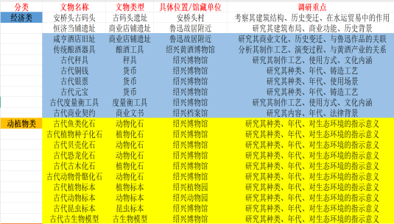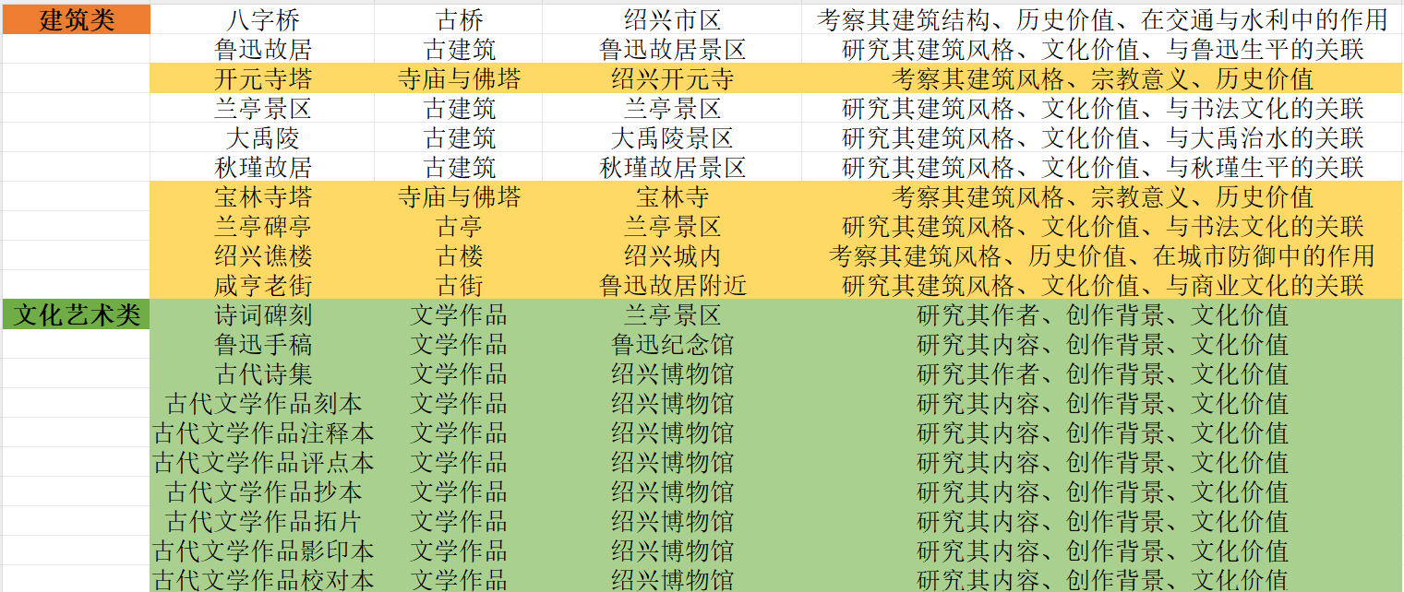
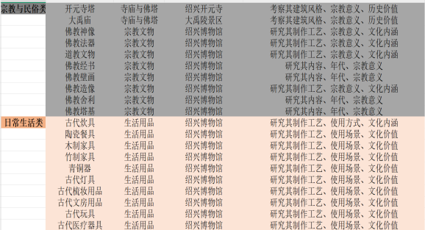
Figure 1 Classification of Cultural Relics
Cultural and artistic artifacts constitute a particularly rich category including stone inscriptions of famous literary works such as the Lantingji Xu and Chaitoufeng poems, manuscript materials from modern literary figures including Lu Xun and Qiu Jin, and various editions of local historical gazettes. Religious and folk artifacts encompass temple structures, Buddhist statuary, Taoist ritual objects, and religious texts that document the spiritual life of canal communities. Daily life artifacts including ceramic vessels from the Yue kiln, bronze implements, furniture, writing materials, and medical instruments provide intimate access to the material conditions of historical existence along the waterway.

3.3 Field Documentation and Data Collection
Field documentation followed standardized protocols developed through the research team’s prior experience and refined through pilot testing. These protocols included high-resolution photographic recording with consistent lighting and framing, dimensional measurement using both traditional and digital tools, condition assessment following heritage conservation standards, and preliminary historical research drawing on local gazettes, family genealogies, and oral historical sources. Team members conducted semi-structured interviews with local residents, cultural heritage officials, and community historians to gather narrative material, verify historical claims, and identify sensitive topics requiring careful handling.
In addition to these methods, the research team also employed spatial analysis techniques. They used Geographic Information System (GIS) to map the spatial distribution of the cultural heritage sites under study. This allowed them to identify patterns and relationships among different sites, such as their proximity to each other, the influence of natural features on their location, and the connection between heritage sites and local settlement patterns.
The team also carried out material analysis on selected heritage objects. By using advanced scientific methods like X-ray fluorescence spectroscopy and thermogravimetric analysis, they were able to determine the composition and origin of the materials used in the construction of the heritage sites. This information was crucial for understanding the technological and cultural aspects of the heritage, as well as for formulating appropriate conservation strategies.
Moreover, the research design incorporated a time-series analysis. By comparing historical records and current field data, the team could track the changes in the cultural heritage over time. This analysis helped in understanding the impact of various factors such as urbanization, natural disasters, and cultural policies on the preservation and evolution of the heritage.
To ensure the reliability and validity of the research, the team implemented a quality control mechanism. They cross-checked the data collected through different methods, and multiple team members independently verified the results of the analysis. Any discrepancies were thoroughly investigated and resolved through in - depth discussions and additional fieldwork.
Finally, the research approach was iterative. Based on the initial findings, the team adjusted their research methods and protocols as needed. This flexibility allowed them to adapt to new discoveries and challenges during the research process, ensuring that the study comprehensively explored the research questions.

3.4 Narrative Design Framework
The development of first-person narratives followed a structured design process informed by literary theory, cognitive psychology, and user experience research. Persona development for each selected artifact involved assigning a distinctive narrative voice incorporating historical context, functional characteristics, and imagined subjective experience grounded in documentary evidence. For example, the Anqiaotou Ancient Wharf was personified as a witness to centuries of commercial exchange, articulating memories of merchant gatherings, cargo loading, social interaction, and environmental change observed from its fixed position along the waterway.

Figure 2 Example of Document Compilation for Cultural Relics
Narrative arc construction for individual artifact stories followed a three-phase structure that enables both historical education and emotional engagement. The origins phase establishes historical context and creation circumstances, drawing on archaeological and documentary evidence to reconstruct the artifact's coming into being. The vitality phase describes peak periods of activity and significance, whether commercial, religious, or domestic, using sensory detail and specific historical events to create immediacy. The transformation phase addresses decline, preservation, and contemporary relevance, connecting historical experience to present-day concerns and future preservation needs. Voice calibration balanced historical authenticity with accessibility, employing first-person pronouns and present-tense narration to create immediacy while maintaining period-appropriate vocabulary and documented historical details to preserve scholarly credibility.

3.5 Multilingual Implementation Strategy
The expansion from bilingual to sextilingual presentation required systematic attention to linguistic and cultural adaptation beyond straightforward translation. The six United Nations official languages Chinese, English, French, Spanish, Russian, and Arabic were selected to maximize global accessibility while acknowledging the geopolitical realities of international communication. Additionally, the local Shaoxing dialect was incorporated to preserve regional linguistic heritage and demonstrate respect for local community identity.

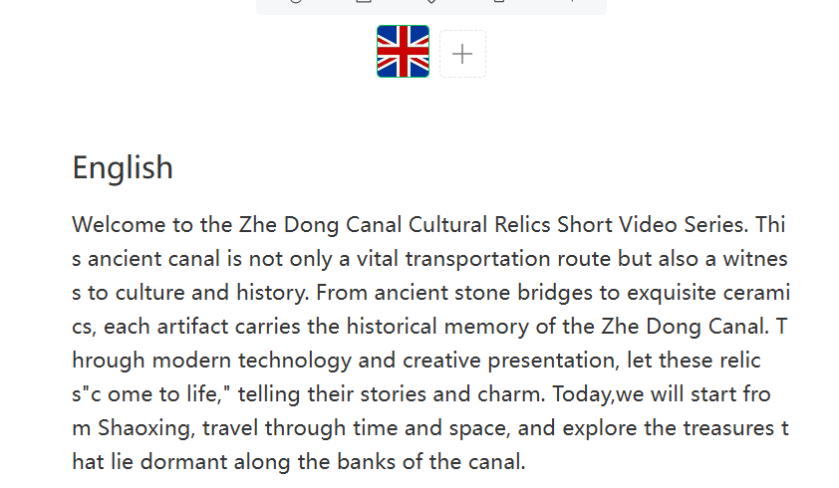
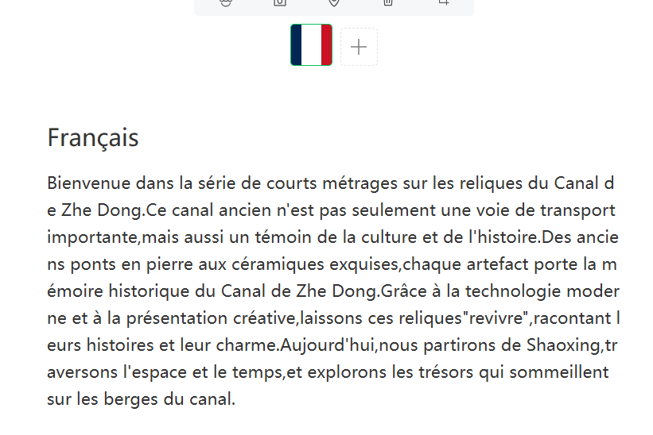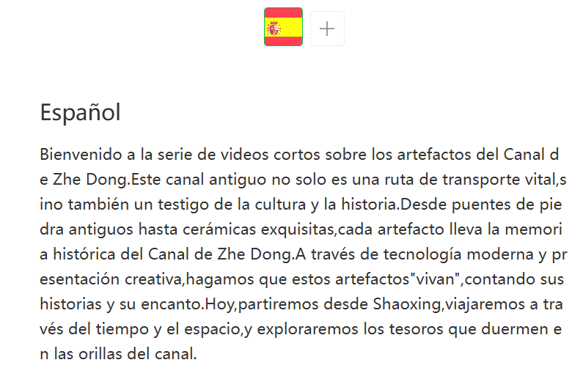
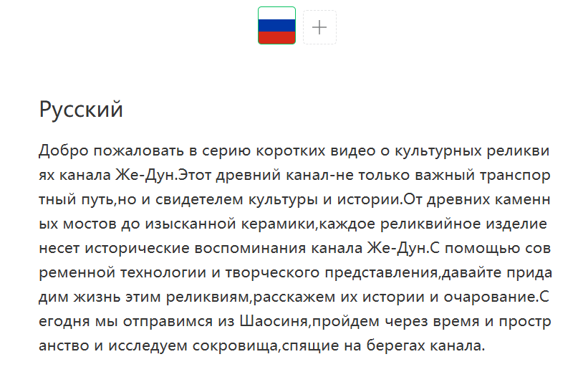
Figure 3 Translation in Six Official Languages of the United Nations
Translation protocol development employed a hybrid approach combining neural machine translation with human revision by native speakers and cultural consultants. Initial drafts were generated using Baidu Cultural Terminology API and Alibaba DAMO Multimodal Translation System, which have demonstrated high accuracy for cultural content in prior applications. Particular attention was devoted to culturally embedded terms including architectural features, social practices, and religious concepts where literal translation would obscure meaning or cause misunderstanding. Cultural localization extended beyond linguistic translation to address diverse cultural backgrounds, with references to specific Chinese historical periods contextualized through comparative reference to broadly recognized historical frameworks, and descriptions of social practices framed to highlight universal human experiences while preserving cultural specificity.
Script variation presented significant design challenges due to the diversity of writing systems represented. Chinese logographic script, alphabetic systems for English, French, Spanish, and Russian, and the Arabic abjad with its right-to-left orientation required distinct approaches to visual presentation and digital typography. The final design adopted flexible grid systems that reversed directional flow for Arabic while maintaining visual hierarchy across all versions, though this solution introduced complexity in multimedia synchronization that required careful technical implementation.

3.6 Digital Platform Development and AI Integration
Content deployment utilized two primary channels: a WeChat public account named Demp plus Zhe Yun Yu Chao incorporating the project logo and visual identity, and an associated video channel with parallel presence on international platforms including Twitter, Instagram, and TikTok. The platform architecture was designed to support one article multiple versions presentation, enabling users to access content in their preferred language while maintaining visual and structural consistency across linguistic versions.
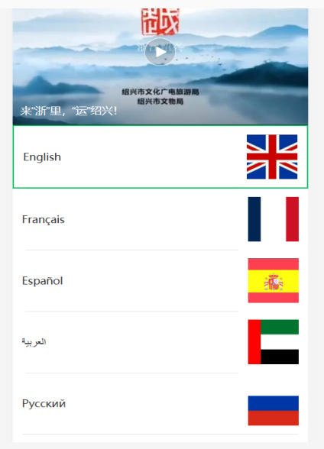
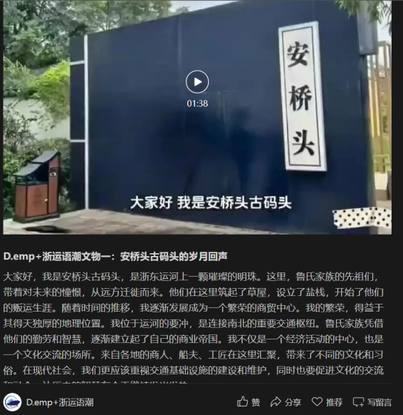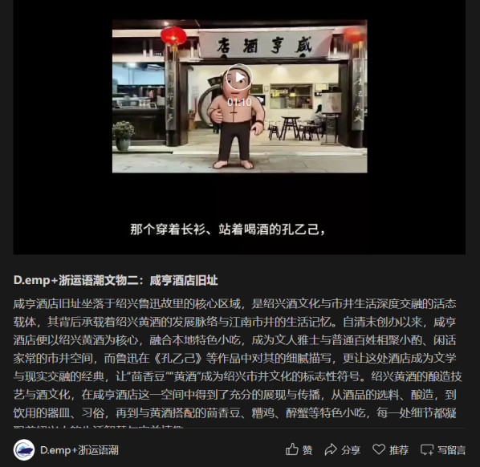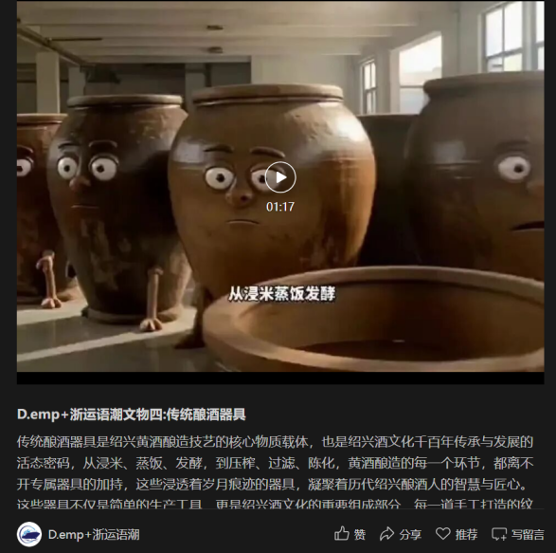
Figure 4 WeChat Official Account Style
AI integration encompassed three primary functions that enhanced the human-centric character of the project. AI-generated voice narration for video content enabled consistent multilingual audio presentation without requiring native speakers for all language versions, though this was supplemented by human voices for key content. AI-assisted image enhancement and historical reconstruction visualization enabled viewers to imagine past states of artifacts and environments now lost to time. Preliminary experimentation with conversational AI interfaces enabled user-artifact dialogue in limited domains, allowing users to ask questions and receive responses generated from the narrative database.

4. Findings and Analysis

4.1 Narrative Transformation and Engagement Metrics
The shift from third-person descriptive cataloguing to first-person narrative representation produced measurable changes in audience engagement patterns that support the human-centric design hypothesis. Analysis of platform analytics from June 2024 through February 2025 reveals significant improvements in engagement metrics across multiple dimensions. Average reading completion rates for first-person narrative articles reached sixty-eight percent, substantially exceeding the forty-two percent completion rate observed for conventional descriptive content in the same publication context. Video content featuring AI-voiced first-person narration achieved two point three times higher sharing rates compared to documentary-style presentations using conventional voice-of-god narration, suggesting that the personalized narrative approach encouraged social distribution.
International audience engagement measured through international platform interactions showed strongest response to narratives emphasizing universal themes including family separation and reunion, economic aspiration and hardship, and environmental change and adaptation, while maintaining cultural specificity in historical detail and local context. This pattern suggests that human-centric AI heritage communication successfully identifies and amplifies shared human experiences across cultural boundaries without reducing cultural difference to homogeneous sameness.
Qualitative analysis of user comments through systematic coding identified recurring themes that support the theoretical framework. Comments frequently referenced feeling personally addressed by the artifact narrators, describing an unexpected emotional connection to historical material previously perceived as distant or abstract, and reporting new perspective on familiar objects encountered through daily life but never previously considered as bearers of historical consciousness. These responses suggest that first-person narration successfully disrupts conventional objectifying gaze, enabling more intimate and empathetic engagement with historical material than traditional museological presentation allows.

4.2 Multilingual Challenges and Cultural Adaptations
The multilingual implementation revealed both technical capabilities and persistent challenges that inform practical recommendations for similar projects. The hybrid AI-human translation workflow achieved satisfactory accuracy for factual content, with verified accuracy for cultural terminology reaching ninety-two percent per Baidu API benchmarks. Cultural consultants' contributions proved essential for adapting narrative tone to cultural expectations, with English versions emphasizing individual agency and dramatic tension, French versions foregrounding aesthetic refinement and historical continuity, Spanish versions highlighting communal celebration and emotional expressiveness, Russian versions emphasizing collective sacrifice and resilience, and Arabic versions foregrounding spiritual values and hospitality traditions.
Persistent challenges emerged in several categories of cultural concept that resisted satisfactory translation through existing AI systems. Poetry and literary allusions central to Chinese cultural heritage discourse often required extensive annotation that disrupted narrative flow or demanded impossible choices between scholarly comprehensiveness and aesthetic economy. Region-specific social practices including particular merchant guild structures, customary measurement systems, and ritual protocols lacked equivalent concepts in target languages, necessitating either foreignization strategies that retained Chinese terms with extensive explanatory notes, or domestication approaches that found rough functional equivalents at the cost of cultural specificity, each with distinct representational implications that required careful ethical consideration.
Visual-textual relations presented substantial design challenges due to the integration of right-to-left Arabic script with left-to-right orientation for other languages. The flexible grid system solution that reversed directional flow while maintaining visual hierarchy required substantial interface adaptation and introduced complexity in multimedia synchronization, particularly for video content where subtitles and narration required precise temporal coordination. These technical challenges, while surmountable, consumed resources that might otherwise have supported content development or community engagement.

4.3 Ethical Considerations in Anthropomorphization
The project generated significant internal debate regarding the ethics of attributing voice and consciousness to material artifacts that have no literal capacity for speech or subjective experience. Historical authenticity concerns were raised by team members and external reviewers who argued that first-person narration, however carefully researched, inevitably involves imaginative projection that may obscure or distort historical actuality in ways that mislead audiences. The response to this concern involved rigorous documentation of all factual claims with clear citation to primary and secondary sources, explicit distinction between documented history and informed speculation clearly marked in the narrative, and provision of conventional scholarly apparatus including bibliographies and archival references for users seeking authoritative information.
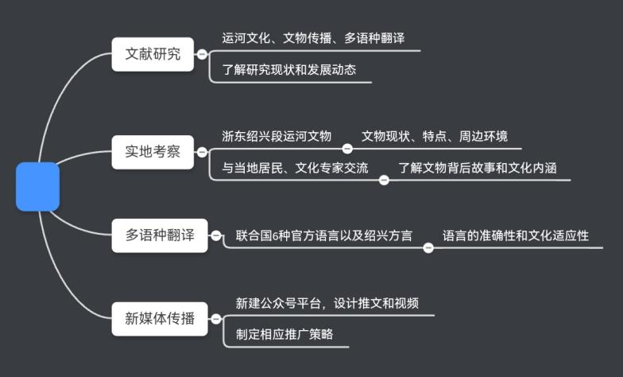
Figure 5 Implementation Process
Cultural appropriation questions arose regarding who possesses the authority to speak for artifacts embedded in specific community histories and family lineages. The project addressed this through extensive community consultation during narrative development, attribution of specific stories to documented oral history sources rather than anonymous composition, and provision of channels for community feedback and correction including comment functions and direct contact mechanisms. These ethical negotiations suggest that human-centric AI in heritage contexts requires not merely technical sophistication but robust frameworks for community accountability and epistemic humility that recognize the limits of digital representation.

4.4 Cross-Cultural Reception Patterns
Analysis of engagement patterns across linguistic and cultural regions revealed distinct preferences that inform future development strategies. English-language audiences showed strongest engagement with narratives emphasizing innovation, economic development, and individual achievement, reflecting cultural values prevalent in Anglophone contexts. French and Spanish audiences demonstrated particular interest in aesthetic and literary dimensions including poetry and artistic representation, suggesting stronger cultural formation in these domains. Russian audiences engaged most strongly with narratives addressing collective sacrifice, resilience, and historical continuity, possibly reflecting national historical experience. Arabic audiences showed preference for content emphasizing spiritual values, hospitality traditions, and environmental stewardship, aligning with cultural priorities in these regions.
These patterns suggest that effective cross-cultural heritage communication requires not merely linguistic translation but cultural framing that resonates with diverse value systems, while avoiding reduction to cultural stereotypes that would undermine the project's human-centric commitments. The AI systems must be designed to support this cultural calibration rather than imposing uniform presentation across diverse audiences.

5. Discussion

5.1 Operationalizing Human-Centric AI in Cultural Contexts
This project’s findings contribute to emerging understanding of how human-centric AI principles can be operationalized in cultural heritage contexts beyond abstract ethical commitments. The research demonstrates that human-centric cannot be reduced to user-friendly interface design or accessibility compliance, but must encompass cultural situatedness that recognizes the partial, positioned nature of all knowledge claims and enables multiple perspectives rather than single authoritative narratives. AI systems must be designed to recognize and adapt to diverse cultural frameworks of meaning, not merely translate between linguistic codes, requiring deep engagement with target cultural contexts during system design rather than post-hoc content adaptation.
Relational agency emerges as a key principle, with heritage artifacts treated not as isolated objects of contemplation but as nodes in networks of human relationships connecting past and present, local and global, human and material in complex webs of significance. AI systems should facilitate these relationships rather than substituting algorithmic determination for human connection, positioning technology as mediator rather than replacement for genuine cultural encounter.
Epistemic transparency proves essential for ethical AI heritage communication, requiring clear communication regarding the limits of AI knowledge and the constructed nature of AI-generated narratives. Users must be enabled to engage critically with heritage content rather than accepting AI-generated narratives as authoritative or objective, through design features that reveal the sources, selection criteria, and interpretive choices underlying the presented content.

5.2 Paradigm Shift in Heritage Communication
The project suggests that AI-enabled first-person narration represents more than a technical innovation or marketing strategy, signaling a potential paradigm shift in heritage communication with profound implications for museological practice. Traditional museology positioned artifacts as objects of expert interpretation and public consumption, maintaining clear hierarchies between professional knowledge and lay appreciation. The digital heritage paradigm emphasized public access and participatory documentation, democratizing information while largely preserving traditional interpretive frameworks. The emerging conversational heritage paradigm exemplified by this project treats artifacts as nodes in networks of ongoing dialogue across temporal and cultural boundaries, fundamentally reconfiguring the subject-object relationship that has structured museum practice.
This shift raises profound questions about authority, authenticity, and the politics of representation that require sustained theoretical and practical attention. If artifacts can speak through AI mediation, who controls their voices and determines what they say? How do we negotiate between competing interpretations when different communities hold conflicting understandings of shared heritage? The project's experience suggests that sustainable implementation requires institutional frameworks for community governance of AI heritage systems that preserve local agency in global representation, preventing the extraction of cultural content for international consumption without benefit to source communities.

5.3 Implications for Regional Heritage Globalization
The Zhejiang Eastern Canal case offers specific insights for broader challenges of regional heritage internationalization that extend beyond this particular context. The project demonstrates that glocalization of heritage requires scalable infrastructure that AI and digital platforms can provide, enabling cost-effective multilingual presentation that would be prohibitively expensive through conventional translation and international travel. However, this scalability must be balanced with adaptive content that articulates universal human values through specific cultural expressions, enabling diverse audiences to recognize both difference and commonality without homogenization.
Community anchoring emerges as essential for ethical heritage globalization, ensuring that international visibility is grounded in local community engagement and benefit-sharing rather than extractive dynamics that appropriate cultural content for external audiences. The project's limitation to six United Nations languages, while practically necessary for resource management, also highlights persistent inequalities in global heritage representation that future development should address through expansion to additional languages, particularly those of diaspora communities with historical connections to canal heritage.

6. Conclusion
This study has explored the application of human-centric AI principles to the international communication of Zhejiang Eastern Canal cultural heritage through first-person narrative strategies and multilingual storytelling. The findings demonstrate that AI technologies, when designed with systematic attention to cultural sensitivity, community accountability, and epistemic transparency, can significantly enhance the accessibility and emotional resonance of regional heritage for global audiences while preserving local particularity and community agency.
The project contributes to three interconnected domains of knowledge and practice. In practical terms, the research develops AI-enhanced heritage communication methodologies that can be adapted to diverse regional contexts, providing specific guidance for narrative design, translation workflow, and platform implementation. Theoretically, the work elaborates human-centric AI in cultural contexts beyond existing policy frameworks, demonstrating how abstract ethical principles can be operationalized in concrete design decisions and institutional arrangements. For policy, the study offers relevant insights regarding regional heritage globalization, community governance of digital representation, and the balance between accessibility and authenticity in international cultural communication.
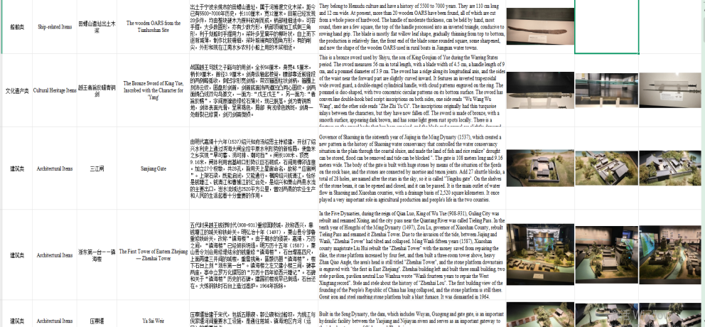
Figure 6 Database Style
Looking forward, several directions merit further investigation and development. The integration of large language models and multimodal AI systems offers possibilities for more sophisticated, responsive artifact personalities capable of genuine dialogue rather than scripted narration, though this raises additional ethical concerns regarding simulation and authenticity that require careful navigation. The development of immersive technologies including virtual reality and augmented reality could extend first-person narrative into embodied, spatial experience that more fully approximates the phenomenological richness of place-based heritage encounter. Most fundamentally, the governance frameworks required for community-controlled AI heritage systems demand sustained interdisciplinary attention combining computer science, heritage studies, legal scholarship, and community development practice.
The Zhejiang Eastern Canal, flowing through two millennia of Chinese history carrying commerce, culture, and human lives along its waterway, now finds new channels of connection to global publics through digital networks and AI mediation. This project suggests that the future of heritage preservation lies not in choosing between technological innovation and humanistic values, nor between local authenticity and global relevance, but in thoughtfully integrating both through human-centric design that enables new forms of cross-cultural understanding and historical imagination. The artifacts that have witnessed centuries of human activity can now speak to contemporary audiences across linguistic and cultural boundaries, not as passive objects of contemplation but as active participants in ongoing dialogue about human experience, memory, and meaning. Through such human-centric AI applications, the heritage of the past can become a resource for the future, enabling diverse communities to recognize their shared humanity while celebrating their distinctive cultural achievements.

References
- F. Vladymyr, Appadurai, Arjun. Modernity at Large: Cultural Dimensions of Globalization. The Russian Sociological Review, 3(4), 57-66, 2003.
- F. Cameron and S. Kenderdine, Theorizing Digital Cultural Heritage: A Critical Discourse, MIT Press, 2010.
- E. Hickman and M. Petrin, “Trustworthy AI and Corporate Governance: The EU’s Ethics Guidelines for Trustworthy Artificial Intelligence from a Company Law Perspective,” European Business Organization Law Review, pp. 1-33, 2021.
- Harrison, “Beyond ‘Natural’ and ‘Cultural’ Heritage: Toward an Ontological Politics of Heritage in the Age of Anthropocene,” Heritage & Society, vol. 8, no. 1, pp. 24–42, 2015.
- H. Liu and M. Chen, “Iconological Reconstruction and Complementarity in Chinese and Korean Museums in the Digital Age: A Comparative Study of the National Museum of Korea and the Palace Museum,” Sustainability, vol. 17, no. 13, pp. 6042, 2025.
- J. W. Elrick, “Staging interactivity: platform logics at the participatory museum,” Science as Culture, vol. 34, no. 2, pp. 218–244, 2025.
- H. Zheng, L. Chen, H. Hu, Y. Wang, and Y. Wei, “Research on the Digital Preservation of Architectural Heritage Based on Virtual Reality Technology,” Buildings, vol. 14, no. 5, 2024.
- W. Jin and H. Fukuda, “Changes of the Northern Zhejiang Canal: Renaissance and Cultural Tourism Development of Ancient Towns,” Sustainability, vol. 16, no. 13, pp. 5464, 2024.
- J. Wang, H. Cao, Q. Cao, J. Chu, and Z. Shi, “Poetic Footprints: Lu You's Life Encounters and Emotional Transformations Along the Zhejiang East Canal,” Highlights in Art and Design, vol. 9, no. 2, pp. 21–28, 2025.
- J. Li, X. Yang, Y. Gao, and C. Gao, “Spatial and temporal distribution characteristics and influencing factors of cultural heritage: A case of the Grand Canal (East Zhejiang section)-maritime silk road,” Plos one, vol. 20, no. 2, e0318529, 2025.

