Breaking Through with Quality: How Innovation Reshapes the International Competitiveness of China's New Energy Vehicles
Li Hehua
He Hongying*
Shanghai Polytechnic University, Shanghai, China
Joanna449@163.comm

ABSTRACT
This study investigates the impact of technological innovation quality on the "volume-price rise" of China's new energy vehicle (NEV) exports. Using monthly data from 2018 to 2024, we construct an innovation quality index - measured by the share of invention patents - and employ a Vector Autoregression (VAR) model for empirical analysis. The findings reveal that: (1) Improvements in innovation quality Granger-cause expansions in export scale and unit price, with impulse responses confirming lasting impacts; (2) The "quality" of innovation substantially outweighs the "quantity" (total patents) in driving export performance, with variance decomposition indicating its contribution is more than double; (3) Innovation quality primarily enhances export unit price through a "premium effect" rather than cost advantages. This research provides robust empirical evidence for latecomer economies to achieve industrial upgrading through quality-oriented innovation policies.
- Introduction
The transition to a green, low-carbon economy elevates the new energy vehicle（NEV） industry to a strategic pinnacle, significantly altering global manufacturing landscapes and labor divisions. Within this context, the remarkable rise of China's NEV sector constitutes a compelling economic phenomenon. China's annual NEV exports skyrocketed from 147,000 units in 2018 to 2.239 million units in 2024, representing explosive growth.

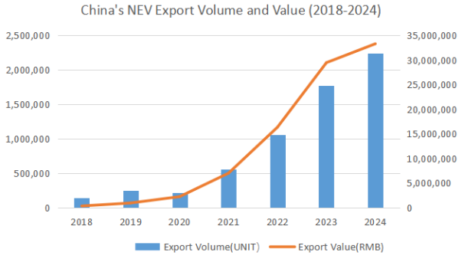
Figure 1.1: China's NEV Export Volume and Value (2018-2024)

Concurrent with this export surge is the optimization of the industry's innovation structure. Substantive innovations, particularly invention patents, show a steady increase, signifying a transition from quantitative growth to qualitative advancements in innovation. This structural shift raises a central economic question: For a latecomer economy, can and how does a quality-driven structural transformation within a specific strategic emerging industry reshape its dynamic comparative advantage in the global market, thereby achieving a "volume-price rise" in exports?

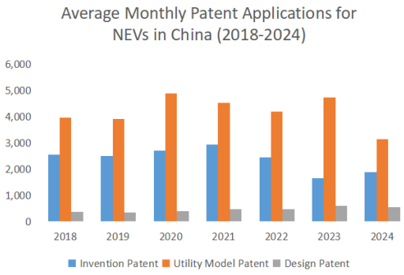
Figure 1.2: Average Monthly Patent Applications for NEVs in China (2018-2024)

Although existing scholarship broadly acknowledges that technological innovation positively affects trade, most of these investigations conceptualize innovation as a monolithic entity, thereby neglecting an in-depth analysis of its qualitative dimensions. In addition, rigorous and systematic studies that investigate the dynamic causal connections between changes in the broader innovation framework and national export success remain scarce. This study, therefore, aims to address three key questions: First, what is the evolutionary path of the innovation structure in China's NEV industry? Second, which contributes more substantially and persistently to export expansion: the upgrading of innovation structure (quality) or the growth in innovation quantity? Third, what are the dynamic interactions among innovation, price, and export scale?

- Literature Review
2.1 Relationship between Enterprise Technological Innovation and Performance Output
Existing literature has conducted multi-dimensional explorations of technological innovation activities and their impacts within new energy vehicle (NEV) enterprises. Regarding innovation measurement, research has evolved from focusing on quantity to emphasizing efficiency and quality. Ruan and Liu (2025) ^{[1]} employed a two-stage dynamic network DEA model to assess the technological innovation efficiency of enterprises under carbon neutrality goals, revealing heterogeneity in the transformation of innovation resources. Wang et al. (2026)^{[2]}, when forecasting NEV sales, comprehensively considered the impacts and cumulative time-delay effects of battery technology innovation and subsidy policies, emphasizing the time-lagged nature of innovation's market influence.

In terms of innovation drivers, Duan and Wang (2025)^{[3]} empirically analyzed the impact of local government policy responses on enterprise technological innovation, finding that proactive policy responses can significantly boost R&D investment. Liu et al. (2025)^{[4]} confirmed a positive correlation between "dual-smart" city construction and industrial technological innovation. Fan and Liu (2025)^{[5]} found that external ESG rating events can act as accelerators for industry innovation, prompting more high-quality innovation. Regarding specific policy instruments, Xue et al. (2025)^{[6]} studied the influence mechanisms of NEV promotion policies, while Li and Xing (2023)^{[7]} analyzed the inducing effect of NEV purchase tax exemption policies on enterprise technological innovation.

Technological innovation ultimately requires market performance to realize its value. Wang, Zhu, and Zheng (2025)^{[8]} empirically tested the relationship between technological innovation and market value, finding that high-quality innovation can significantly enhance a firm's market valuation. Yang et al. (2024)^{[9]} revealed how financial resources promote technological innovation through industry chain transmission. Although these studies explore the influencing factors and output effects of technological innovation from different levels, most remain at the enterprise or industrial meso-level, lacking systematic analysis of how innovation quality translates into export competitive advantages.

2.2 Research on Factors Influencing the International Competitiveness of China's NEV Industry
With the rapid growth of China's NEV exports, the sources of their international competitiveness have garnered attention. On the technological front, Jian et al. (2024)^{[10]}, through an evolutionary analysis of the power battery patent cooperation network, revealed the promoting effect of technological collaboration on industrial innovation. Hu et al. (2024)^{[11]} explored the evolution path of technological change, providing a reference for understanding the direction of technological upgrading.

Regarding policy and market environments, Zhang et al. (2024)^{[12]} analyzed the impact of public policies on China's NEV industry from an institutional economics perspective, emphasizing the shaping role of the institutional environment on industrial development. Mei and Dong (2024)^{[13]} analyzed China's NEV export competitiveness in the dual-carbon context, pointing out new opportunities brought by the green transition. Furthermore, He et al. (2022)^{[14]} found that oil price changes influence the innovation investment of NEV enterprises, thereby affecting long-term competitiveness.

Case studies provide specific references for understanding the formation of competitiveness. Xiao's (2025)^{[15]} case analysis of Tesla Inc. based on value chain theory, and Ling jie's (2025)^{[16]} analysis of the relationship between technological innovation and competitive advantage in the NEV industry using BYD as an example, both reveal how technological innovation translates into market advantages at the enterprise level. While insightful, these case studies are difficult to generalize to the overall industry level.

2.3 Research Gap and Positioning of This Study
Despite existing literature exploring technological innovation and competitiveness in the NEV industry from various angles, the following research gaps remain: Firstly, existing studies either focus on the technological innovation process or analyze export performance, lacking systematic empirical testing of how the quality of technological innovation (particularly the proportion of invention patents) dynamically affects export competitiveness (manifested as "volume-price simultaneous increase"). Secondly, most employ static analytical methods, making it difficult to capture the dynamic causal relationships between variables. Thirdly, there is a scarcity of thorough investigations that adopt a macro-industry viewpoint and utilize high-frequency datasets to explore the linkage between the caliber of innovation and export outcomes.

This study aims to fill these gaps by constructing an innovation quality indicator centered on the "proportion of invention patents" and utilizing monthly data from 2018-2024 with a Vector Autoregression model to empirically test the dynamic driving mechanism of innovation quality on the "volume-price rise" of exports. The research will focus on: whether and how innovation quality simultaneously affects export volume and unit price; the relative importance of "quality" versus "quantity"; and the dynamic interactions among the three variables.

- Methodology and Procedures
To thoroughly evaluate how the structure of innovation dynamically affects export results, this study assembles a monthly time-series database and applies a Vector Autoregression methodology for empirical testing.

3.1. Data Sources and Processing
This study constructs a monthly dataset spanning January 2018 to December 2024. Core variables are defined as follows:
Export Scale: Monthly NEV export quantity (units), transformed using natural logarithm, denoted as ln(Export_Volume).
Export Price: Export Price: Calculated as monthly NEV export value divided by export quantity (in 10,000 CNY per unit), transformed via the natural logarithm, and denoted as ln(Export_Price).
Innovation Quantity: Total monthly patent applications (items), transformed using natural logarithm, denoted as ln(Patent_Total).
Innovation Quality: The share of invention patent applications in the total number of patent applications, denoted as Innovation quality.

New energy vehicles New energy vehicles mainly comprise Battery Electric Vehicles (BEV), Hybrid Electric Vehicles (which include both non-plug-in and plug-in varieties), Fuel Cell Electric Vehicles (FCEV), and other automobiles that employ advanced energy storage systems like supercapacitors or flywheels. This research, referencing customs HS codes and adopting General Administration of Customs of China, chooses export data for NEV products classified under HS codes: 870220, 870230, 870240, 870340, 870350, 870360, 870370, and 870380, covering the period from January 2018 to December 2024.

Table 3.1: New Energy Vehicle Model Classification Table
HS Code | Product Description
870220 | Motor vehicles equipped with both a compression-ignition internal combustion piston engine (diesel or semi-diesel) and an electric motor for propulsion.
870230 | Motor vehicles equipped with both a spark-ignition internal combustion piston engine and an electric motor for propulsion.
870240 | Motor vehicles equipped solely with an electric motor for propulsion.
870340 | Passenger cars with both spark-ignition internal combustion piston engine and electric motor for propulsion (non-plug-in hybrid), of a cylinder capacity not exceeding 1500cc.
870350 | Passenger cars with both compression-ignition internal combustion piston engine and electric motor for propulsion (non-plug-in hybrid), of a cylinder capacity not exceeding 1500cc.
870360 | Passenger cars with both spark-ignition internal combustion piston engine and electric motor for propulsion (plug-in hybrid), of a cylinder capacity not exceeding 1500cc.
870370 | Passenger cars with both compression-ignition internal combustion piston engine and electric motor for propulsion (plug-in hybrid), of a cylinder capacity not exceeding 1500cc.
870380 | Motor vehicles for the transport of persons, equipped solely with an electric motor for propulsion.
Source: General Administration of Customs of China

3.2Variable Selection and Descriptive Statistics
This study aims to examine how the two core explanatory variables—innovation quality and innovation quantity—respectively influence the two dependent variables, export volume and export price, thereby explaining the phenomenon of "volume-price simultaneous increase.
Table 3.2: Descriptive Statistics of Main Variables
Variable | Obs | Mean | Std. Dev. | Min | Max
ln(Export_Volume) | 84 | 10.671 | 1.177 | 7.197 | 12.332
ln(Export_Price) | 84 | 2.163 | 0.796 | 0.155 | 3.111
ln(Patent_Total) | 84 | 8.819 | 0.300 | 7.876 | 9.466
Innovation_Quality | 84 | 0.012 | 0.003 | 0.004 | 0.022
Source: General Administration of Customs of China; China Association of Automobile Manufacturers; National Intellectual Property Administration; PatSnap; compiled by the authors

- Results and Discussion
To rigorously evaluate the driving influence of patent structure enhancement on export outcomes, this section initially performs stationarity examinations on the dataset. Subsequently, based on a stable Vector Autoregression model, the dynamic relationships among innovation quality, innovation quantity, export volume, and price are revealed through Granger causality tests, impulse response functions, and variance decomposition.

4.1. Stationarity Test and Model Specification
Using non-stationary time series directly in regression may lead to spurious results. The ADF test results (see Table 2) indicate that the original level series and their first differences are non-stationary, as the null hypothesis of a unit root cannot be rejected. However, the second-difference series of all variables are stationary at the 1% significance level, confirming they are I(2) processes.

Table 4.1: ADF Unit Root Test Results
Variable | t-Statistic | Prob. | 1% Level | 5% Level | 10% Level | Result
ln(Export_Volume) | -1.692 | 0.435 | -3.514 | -2.898 | -2.586 | Non-stationary
dln(Export_Volume) | -8.780 | 0.000 *** | -3.514 | -2.898 | -2.586 | Stationary
ddln(Export_Volume)* | -5.735 | 0.000 *** | -3.527 | -2.904 | -2.589 | Stationary
ln(Export_Price) | -2.004 | 0.285 | -3.513 | -2.897 | -2.586 | Non-stationary
d ln(Export_Price) | -15.303 | 0.000 *** | -3.513 | -2.897 | -2.586 | Stationary
dd ln(Export_Price)* | -5.102 | 0.000 *** | -3.526 | -2.903 | -2.589 | Stationary
ln(Patent_Total) | -0.089 | 0.951 | -3.526 | -2.903 | -2.589 | Non-stationary
d ln(Patent_Total) | -1.453 | 0.557 | -3.527 | -2.904 | -2.589 | Non-stationary
dd ln(Patent_Total)* | -7.910 | 0.000 *** | -3.527 | -2.904 | -2.589 | Stationary
Innovation_Quality | 0.146 | 0.945 | -3.526 | -2.903 | -2.589 | Non-stationary
d Innovation_Quality | -1.165 | 0.688 | -3.527 | -2.904 | -2.589 | Non-stationary
dd Innovation_Quality* | -7.363 | 0.000 *** | -3.527 | -2.904 | -2.589 | Stationary
Note. ***, **, * denote significance at the 1%, 5%, and 10% levels, respectively .*

As all core variables are I(2) series, the precondition for constructing a VAR model is met. The VAR model is established based on the stationary second-differenced series. The stability test indicates that all inverse roots of the characteristic AR polynomial lie inside the unit circle (see Figure 3), confirming that the specified VAR model is stable, and the results from the impulse response function and variance decomposition are reliable.

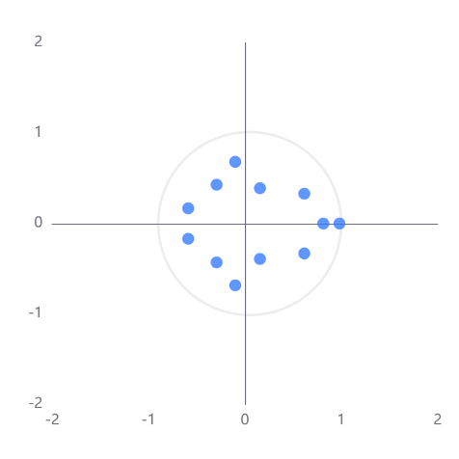
Figure 4.1: VAR Model Stability Test (Inverse Roots of AR Characteristic Polynomial)

4.2. Granger Causality Test
The empirical results reveal that the core driving force is "innovation" (particularly innovation quality). Elevated innovation quality not only directly stimulates an increase in total patent count but also establishes a mutually reinforcing dynamic with it; innovation (whether measured by total patents or innovation quality) is the driver for improving export performance. It facilitates both the expansion of export volume and the attainment of higher export prices, consistent with the “innovation-driven export upgrading” thesis. Additionally, growth in export volume itself exerts an influence on export prices, potentially mirroring economies of scale or shifts in market influence.

Table 4.2: Granger Causality Test Results
Pairwise Sample (Null Hypothesis: X does not Granger Cause Y) | F-Statistic | p-value
ln(Export_Price) → ln(Export_Volume) | 2.176 | 0.120
ln(Export_Volume) → ln(Export_Price) | 3.715 | 0.029**
ln(Patent_Total) → ln(Export_Volume) | 3.622 | 0.031**
ln(Export_Volume) → ln(Patent_Total) | 0.713 | 0.493
Innovation_Quality → ln(Export_Volume) | 3.304 | 0.042**
ln(Export_Volume) → Innovation_Quality | 0.81 | 0.449
ln(Patent_Total) → ln(Export_Price) | 3.415 | 0.038**
ln(Export_Price) → ln(Patent_Total) | 1.24 | 0.295
Innovation_Quality → ln(Export_Price) | 3.437 | 0.037**
ln(Export_Price) → Innovation_Quality | 0.586 | 0.559
Innovation_Quality → ln(Patent_Total) | 5.568 | 0.006***
ln_patent does not Granger Cause quality | 2.799 | 0.067*
Note. ***, **, * denote significance at the 1%, 5%, and 10% levels, respectively.*

4.3. Impulse Response Analysis
The impulse response analysis reveals the direction and pattern of influence, while the variance decomposition quantifies the relative importance of different shocks.

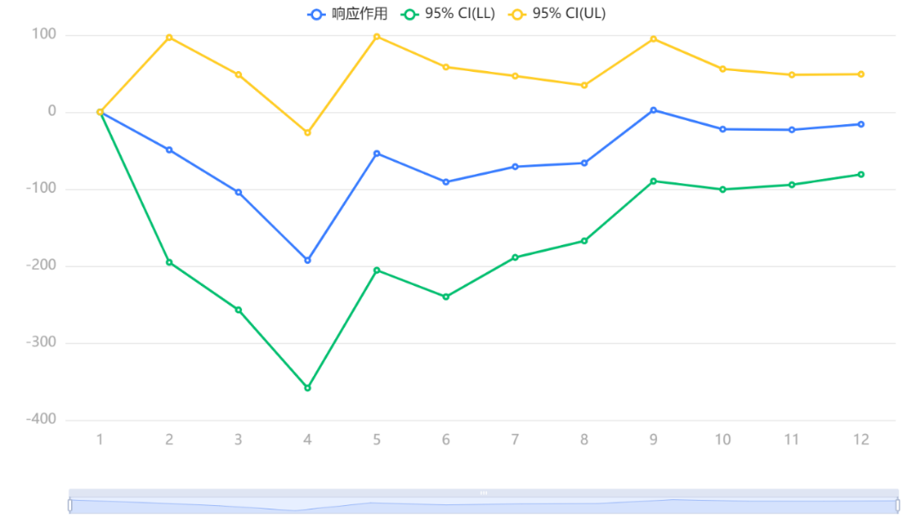
Figure 4.2: Response of Export Volume to Innovation Quality Shock

After giving a positive shock to "Innovation Quality," the export scale shows a significant positive response in the short term, peaking around period 2. This indicates that the optimization of the innovation structure (transition towards higher-value invention patents) can be quickly translated into international market competitiveness, effectively driving the growth of export volume.

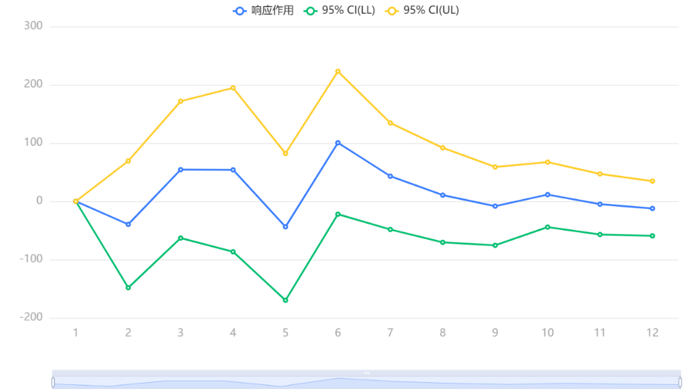
Figure 4.3: Response of Export Price to Innovation Quality Shock

Under the same shock, the response of the export price is more profound. Its positive effect is not only stronger but also maintains a high level throughout the forecasting period with minimal decay. This demonstrates that elevating the quality of innovation is the key pathway for firms to achieve distinct product features, strengthen their ability to set prices, and overcome the challenge of competing primarily on low cost. The premium effect it brings is long-term. The transformation of the innovation structure (quality improvement) can both "expand" exports (increase scale) and "strengthen" exports (increase price), serving as a sustainable driving force for the rise in export value.

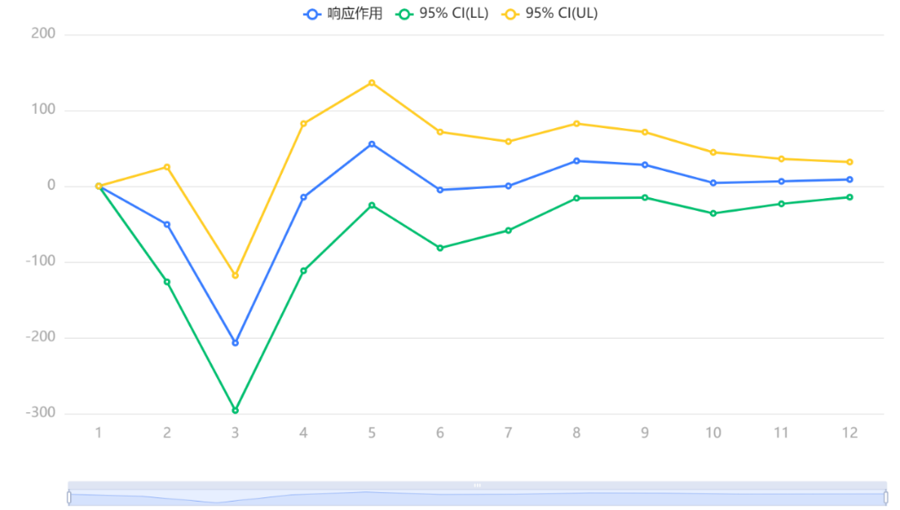
Figure 4.4: Response of Innovation Quantity to Innovation Quality Shock

Comparing the above conclusions with the impulse response graph of "Total Patent Applications" to "Export Price," the effect difference between "quality" and "quantity" can be clearly observed: The limitation of "quantity": Although the shock of the total number of patent applications may also have a weak positive impact on export prices in the short term, its effect strength is far lower than the impact of innovation quality, and its persistence may be shorter. This indicates that simply pursuing the expansion of patent quantity has a relatively limited effect on enhancing the added value of export products. The advantage of "quality": In contrast, the quality indicator "Invention Patent Share" has a superior effect on increasing export prices in terms of strength, persistence, and stability compared to the total patent volume. This strongly proves that in the process of innovation-driven export upgrading, the influence of "quality" far exceeds that of "quantity." The dynamic analysis of impulse responses in this study reveals that the core kinetic energy of China's export upgrading is shifting from the past "quantity expansion" to "quality catch-up." Refining the innovation architecture and elevating the share of invention patents proves to be a more efficacious strategy for steering exports onto a sustainable path of concurrent growth in both volume and unit value, as opposed to merely augmenting the sheer number of patents.

4.4. Variance Decomposition
Variance decomposition quantifies the relative importance of different shocks. By period 12, the contribution of the quality shock to the forecast error variance of ln_volume stabilizes at 8.07%. In contrast, the contribution attributable to a shock in ln_patent (representing innovation quantity) is merely 3.56%. The explanatory capacity of innovation quality exceeds that of innovation quantity by more than a factor of two, thereby providing additional validation for the central conclusion that “quality” predominates over “quantity.” Moreover, the explanatory power of the quality shock is similar in magnitude to that of the price shock (8.26%). This shows that innovation quality is an external factor that is just as crucial as the fundamental price element in accounting for fluctuations in export volume.

Table 4.3: Variance Decomposition of ln_volume
Period | S.E. | ln_volume | ln_price | ln_patent | quality
1 | 0.435 | 100.000 | 0.000 | 0.000 | 0.000
2 | 0.468 | 97.806 | 0.386 | 1.234 | 0.575
3 | 0.536 | 93.304 | 2.436 | 1.855 | 2.405
4 | 0.583 | 87.396 | 2.649 | 2.235 | 7.720
5 | 0.601 | 87.345 | 2.685 | 2.287 | 7.683
6 | 0.621 | 85.717 | 3.817 | 2.148 | 8.318
7 | 0.636 | 84.451 | 4.308 | 2.672 | 8.570
8 | 0.649 | 83.137 | 4.956 | 3.112 | 8.795
9 | 0.658 | 82.220 | 6.000 | 3.225 | 8.556
10 | 0.667 | 81.473 | 6.827 | 3.321 | 8.379
11 | 0.675 | 80.757 | 7.531 | 3.482 | 8.231
12 | 0.683 | 80.121 | 8.255 | 3.556 | 8.068

- Conclusion and Suggestion
This study systematically examines the dynamic impact of innovation quality on the export performance of China's NEV industry. The empirical results consistently demonstrate that innovation quality is the fundamental driver behind the "volume-price rise" phenomenon. A rising proportion of invention patents not only accelerates export volume growth but also, through imbuing products with greater technological sophistication and brand equity, creates a potent and enduring premium impact, leading to a systematic increase in export unit prices. Crucially, the contribution and importance of innovation quality significantly surpass mere patent quantity expansion, marking a historic transition for China's NEV industry from "quantity expansion" to "quality catch-up" as the source of international competitiveness.
These findings carry clear and profound policy implications. For the central government, the focus of industrial policy should shift from "quantity-based" incentives emphasizing R&D input and total patent count towards an evaluation and resource allocation system centered on quality metrics like "invention patent share" and "high-value patent conversion rate." This implies that policy tools such as R&D subsidies and tax benefits must be more precisely targeted towards firms and projects committed to fundamental technology breakthroughs and substantive innovation, thereby guiding the optimization of innovation resources at the national level. For local governments, it is essential to abandon short-sighted practices of blindly pursuing patent numbers in investment attraction and industrial planning. Instead, policy focus should be placed on building a long-term innovation ecosystem conducive to core technology breakthroughs. This includes establishing a robust intellectual property protection regime, breaking down barriers to industry-university-research collaboration, and creating a favorable environment for attracting and retaining high-end innovative talent. Local governments must recognize that a healthy innovation ecosystem is far more supportive of sustainable industrial development and global competitive advantage than short-term patent statistics.
This study has limitations. While monthly macro data effectively illuminates broad industry trends, it does not account for heterogeneity at the firm level, including variations in enterprise scale, ownership models, and market-specific export strategies. Subsequent studies might benefit from incorporating firm-level microdata to more precisely examine how innovation quality distinctly influences the export strategies, market positioning, and upward trajectories within global value chains across diverse enterprise categories. Such an approach would yield more refined empirical support for export upgrading models driven by innovation, while also delivering clearer guidance for the design of differentiated and targeted industrial policies.

Acknowledgments
This research is supported by Shanghai Polytechnic University. The author would like to express sincere gratitude to his supervisor for the invaluable guidance and continuous encouragement throughout this study. The author also extends thanks to the editors and anonymous reviewers for their constructive comments and suggestions.

Funding
This study was supported by grant from Shanghai Polytechnic University.

References

- Zhihua Ruan & Zhikun Liu.(2025).Analysis of Technological Innovation Efficiency in Listed New Energy Vehicle Enterprises Under the Carbon Neutrality Framework Based on Two-Stage Dynamic Network DEA and a GRA Model. World Electric Vehicle Journal,16(11),635-635.
- Junjie Wang, Zifan Wang, Huimin Zhou, Yuanping Ding, Ying Cai & Yaoguo Dang.(2026).Considering the impact and accumulative time-delay effects of the battery technology innovation and subsidy policy for predicting the new energy vehicle sales. Computers & Industrial Engineering,212,111674-111674.
- Duan X ,Wang Y .A Study on the Impact of Local Policy Response on the Technological Innovation of the New Energy Vehicle Industry[J].Sustainability,2025,17(19):8873-8873.
- Dehai Liu, Shaoyan Fu, Huiyun Li & Fuqiang Huang.(2025)."Dual-Smart" city construction and technical innovation: Evidence from China's new energy vehicle industry.Energy,335,138253-138253.
- Yu Fan & Yang Liu.(2025).Sustainable drive: External ESG rating events serve as an accelerator for innovation in the new energy vehicle industry. Energy Strategy Reviews,61,101874-101874.
- Yawei Xue, Chunqian Zhu & Yuchen Lu.(2025).Research on the Influence Mechanism of New Energy Vehicle Promotion Policy.Sustainability,17(8),3699-3699.
- Li Weibing & Zhang Xing.(2023).Can the Exemption of the New Energy Vehicle Purchase Tax Policy Induce Technological Innovation of Automobile Companies? Environmental science and pollution research international,30(45),101669-101680.
- Xuanwen Wang, Lei Zhu & Haitao Zheng.(2025).The relationship between technical innovation and market value: Evidence from the China's new energy vehicles industry. Energy Policy,202,114606-114606.
- Kexin Yang, Qi Zhang, Qiqi Liu, Jiangfeng Liu & Jie Jiao.(2024).Effect mechanism and efficiency evaluation of financial support on technological innovation in the new energy vehicles’ industrial chain.Energy,293,130761-.
- Xue Jian, Fan YiXue & Lv Yang.(2024).The evolution of patent cooperation network for new energy vehicle power battery.SN Business & Economics,4(7).
- Ruifeng Hu, Teng Cai & Weiqiao Xu.(2024).Exploring the technology changes of new energy vehicles in China: Evolution and trends. Computers & Industrial Engineering,191,110178-.
- Zhang Shurui,Deng Lin,Zhou Wei & Zhang Lei.(2024).The impact of public policies on China’s new energy vehicles from the perspective of institutional economics.E3S Web of Conferences,565.
- Mei Yuping & Dong Qianqian.(2024).Analysis of China’s New Energy Vehicle Export Competitiveness in a Dual-Carbon Context. Proceedings of Business and Economic Studies,7(6),1-8.
- He Jiaxin,Li Jingyi, Zhao Daiqing & Chen Xing.(2022).Does oil price affect corporate innovation? Evidence from new energy vehicle enterprises in China. Renewable and Sustainable Energy Reviews,156.
- Yao Xiao.(2025).A Case-study on Tesla Inc. Based on the Value Chain Theory. Academic Journal of Business & Management,7(10).
- Zhu Lingjie.(2025).Analysis of Technological Innovation and Competitive Advantage in New Energy Vehicle Industry: BYD as an Example. SHS Web of Conferences,218,01031-01031.

